Isis’s Contributors and Intellectual Contexts, 1953–2023
Melinda Baldwin, University of Maryland, College Park
Gerardo Ienna, Marie Skłodowska-Curie Global Fellowship at University of Verona

Abstract: In this essay, we examine the institutional afﬁliations of Isis contrib- utors and editors in the second half of the twentieth century and the ﬁrst decades of the twenty-ﬁrst, and analyze what the articles and book reviews in Isis suggest about contributors’ engagement with the ﬁeld of science studies more broadly. For much of the late twentieth century, we argue, Isis was a US-dominated journal, in terms of both the afﬁliations of its contributors and the intellectual trends it en- gaged with. Methodological developments in European science and technology studies (STS), for example, were generally not reﬂected in Isis’s research content until many years after they were originated, although the Isis book reviews fre- quently considered books by STS researchers. This US dominance has begun to change in recent years, however, with the establishments of editorial ofﬁces outside the United States and an increasing number of contributions from scholars outside the US. Current citation patterns in Isis reveal that the journal’s research articles re- ﬂect strong engagement with STS more broadly.

INTR ODUC TION
1
953 was the ﬁrst year that George Sarton did not serve as Isis’s editor in chief. In an editorial announcing the change, HSS President Dorothy Stimson praised Sarton’s stewardship of

Melinda Baldwin is the AIP Endowed Professor in History of Natural Sciences at the University of Maryland, College Park. She is the author of Making “Nature”: The History of a Scientiﬁc Journal (University of Chicago Press, 2015) and is currently working on a book on the origins of peer review in the sciences. 2101J Francis Scott Key Hall, 4282 Chapel Lane, University of Mary- land, College Park, MD 20742-7315; mbaldwin@umd.edu.
Gerardo Ienna is a Marie Skłodowska-Curie Global Fellow (MISHA, Horizon 2020; GA: 101026146) at the University of Ve- rona and the University of Maryland. He completed his PhD in 2019 and was subsequently a postdoctoral fellow at the Univer- sity of Verona and Ca’ Foscari University of Venice. He has published various articles and essays devoted to Marxist historiog- raphy of science, science and technology studies, history of science diplomacy, and radical science movements. He also recently published two monographs devoted to reconstructing debates in the ﬁeld of historical epistemology. His present research project aims at reconstructing transnational collaborative networks within the Radical Science Movements in the US, UK, Italy, and France. Via San Francesco 22, Verona 37129, Italy; gerardo.ienna@gmail.com.
Acknowledgments: The authors would like to thank Eugenio Petrovich for support related to the scientometric part of the article and our anonymous referee for helpful comments. For this project, Ienna has received funding from the European Union’s Ho- rizon 2020 research and innovation program under Marie Skłodowska-Curie grant agreement no. 101026146. In addition, we are grateful to the History Department of the University of Maryland for providing a stimulating discussion environment.

633

634

“our—or more properly his—journal.”1 It was a moment of profound change for Isis, and not just because of Sarton’s retirement. The History of Science Society was transitioning to a full- ﬂedged professional society, and at the same time, university classes and positions in the history of science were growing in number.2 Those changes would shape the professional status of Isis contributors, as well as the intellectual movements they brought to their scholarship and to the journal’s pages. In this essay, we take a closer look at who was contributing to Isis in the second half of the twentieth century and the ﬁrst decades of the twenty-ﬁrst, and analyze what the ar- ticles and book reviews in Isis suggest about contributors’ engagement with the ﬁeld of science studies more broadly.
In this issue, Bernard Lightman and Christine Luk trace the History of Science Society’s com- mitment to internationalism and show that HSS has consistently striven to be an international so- ciety. However, we ﬁnd that internationalism was not always reﬂected in the Society’s most impor- tant journal. For much of the late twentieth century, we argue, Isis was a US-dominated journal, in terms of both its contributor base and the intellectual trends it engaged with. Methodological de- velopments in European science and technology studies (STS), for example, were generally not reﬂected in Isis’s research content until many years after they were originated. This US dominance has begun to change in recent years, however, with the establishments of two editorial ofﬁces out- side the United States (one in Canada, one in the Netherlands), an expansion of the methodolog- ical interests represented on Isis’s pages, and an increasing number of contributions from scholars outside the US.

ISIS ’ S E DITORI AL BOAR D A ND CONTR I BUTOR B AS E
Following Sarton’s resignation, responsibility for Isis was handed over to an editorial board with Sarton protégé I. Bernard Cohen serving as the board’s chair.3 The post-Sarton editorial board included scholars from the University of Wisconsin, Cornell, Yale, City College of New York, Uni- versity of Pennsylvania, and Sarton’s home institution, Harvard. There was one notable gap in the 1953 editorial board’s geography, however: not a single member held a position outside the United States. In the half-century following Sarton’s departure, the Isis editorial team would remain heavily US-dominated. In 1956, HSS decided to restore the position of editor in chief, and Cohen was ofﬁcially named to it. Over the next several decades, Isis’s editorial ofﬁces moved around the United States, but it would not be until 2003 that Isis’s editorial ofﬁces moved outside the US, and not until 2014 that Isis had an editorial ofﬁce outside North America (see app. A for a list of Isis editors).
Like most editors of scholarly journals, the editors in chief of Isis all maintained an editorial board of scholars in different research areas. There were two types of editorial advisors listed on the Isis masthead: members of the HSS Committee on Publications (before 1971 called the Editorial Committee, and from 1971 to 1985 called the Committee on Isis), who bore heavier responsibility for the running of the journal, and the larger group of Advisory Editors (before 1971 called Editorial Consultants). Throughout the twentieth century the overwhelming majority of both Committee members and Advisory Editors were employed at universities in the United States.

1 Dorothy Stimson, “The Editing of Isis,” Isis 44 (1953): 3.
2 See Bernard Lightman and Christine Y. L. Luk, “One Hundred Years of Internationalizing the History of Science,” in this issue.
3 On Sarton’s legacy for the ﬁeld and the development of the history of science ﬁeld in the US, see Arnold Thackray and Robert
K. Merton, “On Discipline Building: The Paradoxes of George Sarton,” Isis 63 (1972): 472–95; Christopher Hamlin, “The Ped- agogical Roots of the History of Science,” Isis 107 (2016): 282–308; and Lightman and Luk, “One Hundred Years of Interna- tionalizing the History of Science.”

635

We see similar US dominance of the Isis contributor list.4 We constructed a data set of Isis research articles and letters from 1956 to 2023, which allowed us to identify the top ten Isis contributor institutions for each decade (see app. B).5 The overwhelming majority of the insti- tutions on this list (sixty-one out of eighty listings, or 76%) are located in the US, and only three institutions—Utrecht University, the Max Planck Institute, and CNRS—are located in non- English-speaking countries. Appendix B also illustrates that the most frequent contributor institutions were responsible for a signiﬁcant portion of Isis research articles. Over the past sev- enty years, roughly one in four Isis articles has come from one of the top ten contributor in- stitutions. Editorial regimes have also made a signiﬁcant difference. The Netherlands-based ed- itorship of H. Floris Cohen, for example, correlates with a marked increase in contributions from Europe; the Max Planck Institute and Utrecht University top the list of contributor insti- tutions for the most recent twelve years.

TOPICS A N D M ETHODOLOGI CAL A PPR OACHES I N ISIS
Isis in the 1950s and 1960s may not have ﬁt Sarton’s vision of a journal with a broad interna- tional editorial and contributor base. But in the early post-Sarton years of Isis, the subjects of the articles reﬂected broad geographic interests. During the 1950s and early 1960s there was a heavy chronological emphasis on science prior to 1800, and the most frequently recurring subjects tended to be well-known ﬁgures like Newton and Copernicus. Nearly every issue of Isis had at least one article about science outside Europe. That began to shift around the late 1960s. Even as the nineteenth and (more slowly) twentieth centuries became more frequent chronological foci, and as American history of science became the focus of more scholarship, the number of articles about science outside Europe and the US began to decline.6 By the 1970s and 1980s it was possible to read several issues of Isis in a row without seeing a single article on non-Western science. In the late 1990s Isis articles began to reﬂect a resurgence of interest in non-Western topics, supplemented in the 2010s by a rich and growing literature on transnational science.
We can also track methodological trends in the history of science through the pages of Isis. In the 1950s, 1960s, and early 1970s, most Isis articles focused on the work of a single ﬁgure or on the history of a particular scientiﬁc theory—in other words, they used an internalist ap- proach consistent with founding ﬁgures in the history of science including Sarton himself, Alexandre Koyré, Cohen, Herbert Butterﬁeld at Cambridge, and Charles Gillispie at Princeton. This seems to have been a deliberate choice on the part of at least some historians of science who felt that the social aspects of the history of science were best left to sociologists. “Sociology of science,” wrote contributor Harry Alpert in 1963, covered the “demography and economics of science, the structural and processual interrelations of science and society, the social psychology of scientiﬁc creativity, and the social, cultural, and psychological characteristics of scientists.”7 The externalist-Marxist approaches proposed by authors such as Boris Hessen, Edgar Zilsel, John

4 Robert Fox made a similar observation in his 1990 review of Isis for a special Isis issue on history of science journals, writing, “According to my rough analysis . . . of the papers over the last ten years, three quarters have come from the United States.” Robert Fox, “Review of Isis: An International Review Devoted to the History of Science and Its Cultural Inﬂuences,” Isis 81 (1990): 288.
5 Our data set began with data pulled from Web of Science (WoS); however, at the time of writing, WoS provided a data set with
a signiﬁcant amount of missing data, including some missing articles and many missing institutional afﬁliations. The authors ﬁlled in all gaps using the information as printed in Isis. Data set available upon request. Note that there are many instances where multiple universities contributed identical percentages, and so the table often lists more than ten institutions per decade.
6 On the growth of Americanist history of science, see Lightman and Luk, “One Hundred Years of Internationalizing the History
of Science.”
7 Harry Alpert, “Science Records: Viewpoints of the Sociology of Science,” Isis 53 (1962): 67.

636

Desmond Bernal, Joseph Needham, Franz Borkenau, and Henryk Grossmann struggled more to gain legitimacy among Western historians of science.
During the early 1980s, however, articles in Isis began to reﬂect more social and cultural history. That growth coincided with the editorship of Arnold Thackray, who had established the interdisciplinary History and Sociology of Science Department at the University of Penn- sylvania, and it seems likely that more historians felt encouraged to submit pieces with a social and cultural approach to an editor whom they suspected might regard them favorably. Articles in Isis increasingly focused not just on the great theories and major ﬁgures of the history of science, but on scientiﬁc institutions; the intersection of science with politics, literature, and art; and the social and cultural status of the sciences in different times and places. The turn toward social and cultural history of science continued in the 1980s and 1990s and is still pre- sent in Isis to this day.
Thus far, this essay has focused on the research articles in Isis, but another important component of Isis was (and is) its book reviews. Reviews of new monographs in the history of science had been a key feature of Isis under Sarton and continued to occupy a signiﬁcant percentage of the journal’s page count. The ﬁrst post-Sarton volume of Isis in 1953, for example, had 77 pages of book reviews out of 405 pages total (19% of total page count). That percentage grew dramatically in the 1980s as Isis began to aspire to comprehensive coverage of new scholarly monographs in the history of sci- ence; 33.8% of the 1980 volume, 40.5% of the 1985 volume, and a whopping 47.5% of the 1990 volume were dedicated to book reviews. In the twenty-ﬁrst century that percentage has stabilized at around 30%–35% of the average volume. While most Isis reviews have been short—two columns or less—Isis has also been a home for longer book review essays that advance original historical ar- guments based on an analysis of the secondary literature. Generally speaking, the book reviews re- ﬂected the same broad historiographical trends as outlined in the research articles, with one impor- tant exception: Isis book reviews showed far more interest in, and engagement (though not always favorable) with, the philosophy and sociology of science.

HIST ORY O F S CIENCE AND S TS IN ISIS
This section is devoted to analyzing the position of science and technology studies (STS) in Isis, with a special focus on the sociology of scientiﬁc knowledge (SSK) approach developed in Europe. As previously mentioned, the community of early historians of science was reluctant to adopt sociological approaches in their research practice. Despite this, many early issues of Isis in- cluded articles and book reviews related to the sociology of science. Sarton, together with sociolo- gist Pitirim A. Sorokin, was a supervisor of Robert K. Merton’s doctoral dissertation, which was pub- lished in Isis’s sister journal, Osiris, in 1938.8 In the years that followed, Isis welcomed many articles by Merton and others from the Mertonian sociological school.9
As has been recounted elsewhere, the SSK branch of STS emerged in the second half of the 1960s through the founding of a few research centers in the UK, then spread rapidly to other European countries such as France, the Netherlands, Austria, and Germany. SSK proponents

8 Robert K. Merton, “Science, Technology and Society in Seventeenth Century England,” Osiris 4 (1938): 360–632.
9 See, e.g., Robert Merton, “The Matthew Effect in Science, II. Cumulative Advantage and the Symbolism of Intellectual Prop- erty,” Isis 79, no. 4 (1988): 606–23, which is the most cited Isis article ever. In addition, many books from the Mertonian school have been reviewed in Isis. See, e.g., Timothy Lenoir, “Review of Science, Technology, and Society: Twentieth-Century Style, by Robert K. Merton, Jerry Gaston, and Stuart S. Blume,” Isis 70, no. 1 (1979): 152–53; and Thomas F. Gieryn, “Review of Social Studies of Science, by B. Barber,” Isis 83, no. 1 (1992): 179–81.

637

aimed to radically renew meta-scientiﬁc debates through a rejection of older sociology of science approaches, which they said were incapable of analyzing the contents of scientiﬁc knowledge.10
The Isis book reviews are a useful starting point for understanding the interactions between SSK and the history of science. During the emergent phase of European SSK in the 1960s and 1970s, Isis began running reviews of some pivotal volumes from this new intellectual trend. For example, the historian of science Nathan Reingold praised two major books outlining the SSK “Strong programme”: Scientiﬁc Knowledge and Sociological Theory by Barry Barnes and Knowledge and Social Imagery by David Bloor.11 Around the same time, European-based his- torians of science close to SSK such as Roy MacLeod, Steven Shapin, and Simon Schaffer were also beginning to publish their ﬁrst articles or book reviews in Isis. It is worth noting that many of the ﬁgures we will discuss in this section wore multiple methodological hats, often blending historical analysis with STS approaches.
In the early 1980s, major SSK authors such as Barry Barnes, David Bloor, Harry M. Collins, Andrew Pickering, Donald MacKenzie, Trevor Pinch, Bruno Latour, and Steve Woolgar began to write book reviews and essay reviews for Isis. These authors advanced discussion on SSK using a twofold strategy. First, they wrote positive reviews of SSK-focused books for the Isis book reviews section.12 Second, they harshly criticized some texts that drew from older approaches to sociology.13 Some Isis reviewers, however, regarded books from the SSK tradition with more skepticism. Collins’s introductory volume on SSK received sharp criticism, as did the edited volume Science Observed.14 However, Opening the Pandora’s Box by Nigel Gilbert and Michael Mulkay, and Lab- oratory Life by Latour and Woolgar, received warm reviews laced with only mild skepticism.15 Shapin and Schaffer’s Leviathan and the Air Pump was enthusiastically reviewed by historian of science Margaret Jacob, who deemed the book “a remarkable achievement, a pleasure to read.”16 By the 1990s, more and more Isis contributors were making use of SSK approaches, as evidenced by a classic 1990 Jan Golinski article.17 The 1990s were also marked by the grad- ual opening of Isis to the inﬂuences of feminist STS and the intersection with postcolonial

10 For a general overview on the STS and SSK debates, see D. J. Hess, Science Studies: An Advanced Introduction (New York: New York University Press, 1997); Sergio Sismondo, An Introduction to Science and Technology Studies (Malden, MA: Wiley- Blackwell, 2010); and Massimiano Bucchi, Science in Society: An Introduction to Social Studies of Science (London: Routledge, 2004).
11 Nathan Reingold, “Review of Scientiﬁc Knowledge and Sociological Theory; Knowledge and Social Imagery, by B. Barnes & D.
Bloor,” Isis 68 no. 4 (1977): 625–26.
12 See, e.g., Harry M. Collins, “Review of Interests and the Growth of Knowledge, by B. Barnes,” Isis 71, no. 1 (1980): 159–60; Bruno Latour, “Review of Rationality and Relativism, by Martin Hollis & Steven Lukes,” Isis 76, no. 2 (1985): 241–42; and
D. Edge, “Is There Too Much Sociology of Science?” Isis 74 no. 2 (1983): 250–56.
13 See, e.g., Steve Woolgar, “Review of The Reward System in British and American [J. Gaston],” Isis 72, no. 2 (1981): 297–98; and Harry M. Collins, “Review of The Sociology of Science: Problems, Approaches, and Research, by J. Gaston,” Isis 71, no. 3 (1980): 487–88.
14 Ian Inkster, “Review of Sociology of Scientiﬁc Knowledge: A Source Book, by H. M. Collins,” Isis 75, no. 3 (1984): 577–78; and
David Philip Miller, “Review of Science Observed: Perspectives on the Social Study of Science, by Karin Knorr-Cetina & Michael Mulkay,” Isis 76, no. 1 (1985): 97–98.
15 Bernard Barber, “Review of Opening Pandora’s Box: A Sociological Analysis of Scientists’ Discourse, by G. Nigel Gilbert &
Michael Mulkay,” Isis 76, no. 1 (1985): 95–97; and Donna Haraway, “Review of Laboratory Life: The Social Construction of Scientiﬁc Facts, by B. Latour & S. Woolgar,” Isis 71, no. 3 (1980): 488–89.
16 Margaret C. Jacob, “Review of Leviathan and the Air Pump: Hobbes, Boyle, and the Experimental Life, by S. Shapin & S.
Schaffer,” Isis 77, no. 4 (1986): 719–20.
17 Jan Golinski, “The Theory of Practice and the Practice of Theory: Sociological Approaches in the History of Science,” Isis 81, no. 3 (1990): 492–505.

638

approaches, with reviews of works by authors such as Helen Longino, Sandra Harding, and Donna Haraway.18 More recently, in 2017, Isis dedicated one of its “A Second Look” special sections to Shapin and Schaffer’s Leviathan and the Air-Pump, now recognized as a “classic” in both SSK and the history of science.

CONCLUSION: ISI S AND S CIENCE STUDIES I N T H E TWENT Y - FIRS T C ENTURY
The continuing relevance of STS approaches to the history of science in recent decades is evi-
denced by the citations from this ﬁeld in research articles published in Isis. Figure 1 contains a map of the most frequently co-cited authors (i.e., authors who are often cited together in the notes of the same article) in articles published in Isis between 2010 and 2022.19 The size of each of the nodes is determined by the number of citations received by each item within the data set, and the thickness of the links is determined by the number of times the two nodes appear cited together in the data set. The proximity of the nodes is determined by the strength and frequency of the var- ious co-citation relationships, so that frequently co-cited authors will appear closer on the map.20 The position of Shapin, Schaffer, and Latour thus suggests not only that they have been frequently cited but that they entertain strong co-citational relationships with each other and with the other authors present in the network, indicating that the SSK literature is frequently cited in the pages of Isis. Other inﬂuential authors whose work has combined STS and history of science approaches, such as Ian Hacking and Donna Haraway, also occupy relevant positions within the network.
This thesis is further conﬁrmed by ﬁgure 2, which processes the same data but constructs the network of co-citations for the periodicals cited in Isis references. The most frequently cited periodicals are other history of science journals, including Isis itself. The STS ﬂagship journal Social Studies of Science is the sixth-most-cited journal and the ﬁrst not explicitly devoted to the history of science, and other STS journals such as Science, Technology, and Human Values and Minerva also appear on the map in prominent positions. It is also unsurprising that jour- nals such as Current Anthropology and American Anthropologist appear in the network, given the role that cultural anthropology plays in science studies. Through this map we can see that Isis’s engagement with the ﬁeld of science studies more broadly is not simply about growth in citations of a few canonical STS authors, but reﬂects engagement with an entire disciplinary ﬁeld.
As the History of Science Society enters its 100th year, it is clear that its ﬂagship journal is embedded in an interdisciplinary network of citations. The data on Isis’s contributors, more- over, indicate that the journal increasingly reﬂects and attracts an international community of scholars.

18 Jerry Ravetz, “Review of Science as Social Knowledge: Values and Objectivity in Scientiﬁc Inquiry, by H. E. Longino,” Isis 82, no. 3 (1991): 602–3; Gerard Fergerson, “Review of The ‘Racial’ Economy of Science: Toward a Democratic Future, by Sandra Harding,” Isis 86, no. 1 (1995): 89–91; and Hilary Rose, “Review of Feminism and Technoscience, by D. J. Haraway,” Isis 89, no. 3 (1998): 565–66.
19 The data set was extracted from Web of Science and contains 508 articles published on Isis between 2010 and 2022 (we chose
to exclude other sections such as book reviews, essay reviews, and bibliography from the count). The network is visualized using the software VOSviewer. We chose not to present data from earlier than 2010 because the Web of Science has gaps and frequent errors.
20 The technical literature on this subject is extensive. For details on VOSviewer, see esp. Nees Jan van Eck and Ludo Waltman,
“Software Survey: VOSviewer, a Computer Program for Bibliometric Mapping,” Scientometrics 84, no. 2 (2010): 523–38.

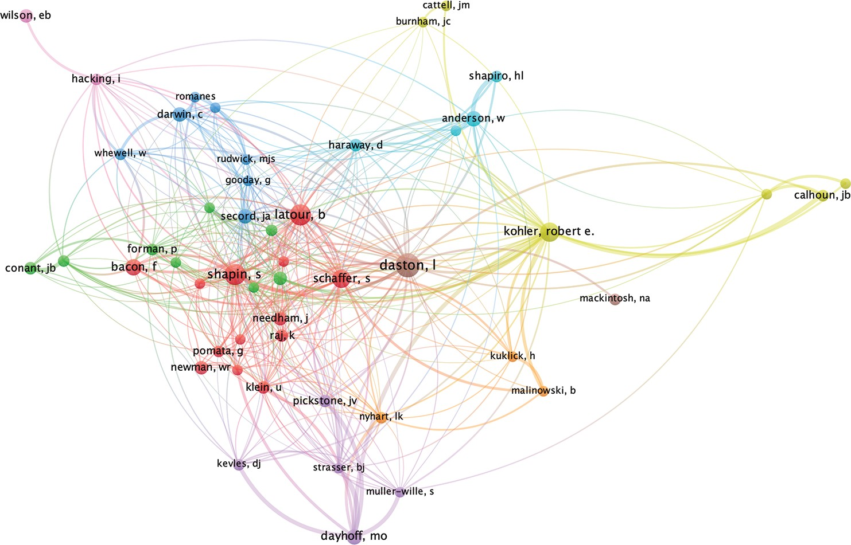

Figure 1. Co-citation of cited authors in Isis for the period 2010–2022, full counting (min. 20 citations). Colors are assigned by VOSviewer clustering algorithm.

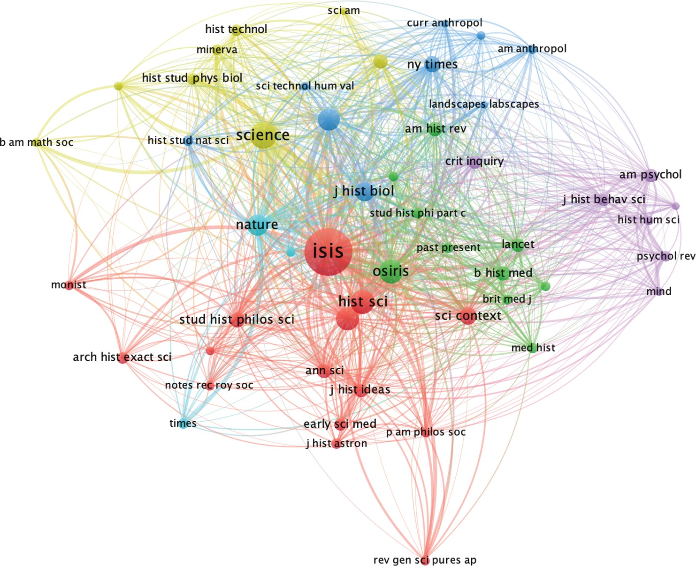

Figure 2. Co-citation of cited sources on Isis for the period 2010–2022, full counting (min. 20 citations).

640

Appendix A. Isis’s Editors in Chief, 1956–Present

Editor(s) in chief (years served) | Editor’s institutional afﬁliation (location)
I. Bernard Cohen (1956–1958) | Harvard University (USA)
Harry Woolf (1959–1964) | University of Washington, 1959–1961 (USA) and Johns Hopkins University, 1961–1964 (USA)
Robert P. Multhauf (1964–1978) | Smithsonian Museum of History and Technology (USA)
Arnold Thackray (1979–1985) | University of Pennsylvania (USA)
Charles Rosenberg (1986–1988) | University of Pennsylvania (USA)
Ronald Numbers (1989–1993) | University of Wisconsin Madison (USA)
Margaret Rossiter (1994–2003) | Cornell University (USA)
Bernard Lightman (2004–2013) | York University (Canada)
H. Floris Cohen (2014–2018) | Utrecht University (Netherlands)
Alexandra Hui and Matthew Lavine (2019–present) | Mississippi State University (USA)

Isis—Volume 115, Number 3, September 2024
641

Appendix B. Top 10 Isis Contributor Institutions + % of Articles Contributed by Decade, 1953–2022

1953–1959 | 1960–1969 | 1970–1979 | 1980–1989
- Harvard 6.8%  - Columbia 4.7%  - Wisconsin 3.4%  4. MIT 2.4%  - Cornell 2.1%  - Cambridge 1.5%  - Berkeley 1.3%  - Johns Hopkins 1.1%  - Yale 1.1%  - (tie) Kansas 0.8%  Pennsylvania 0.8%  TOTAL (top 11) 25.9% | - Harvard 4.5%  - Cornell 2.7%  - Cambridge 2.6%  - Columbia 2.4%  - Princeton 2.1%  - Pennsylvania 1.8%  - Yale 1.8%  8. MIT 1.6%  9. (tie) Leeds 1.1% Kansas 1.1%  Manchester 1.1%  Wisconsin 1.1%  TOTAL (top 12) 23.7% | - Wisconsin-Madison 4.4%  - U Toronto 3.5%  - Berkeley 2.9%  - (tie) Yale 2.0%  York U 2.0%  6. (tie) U London 1.8% Harvard 1.5%  Cambridge 1.5%  UCLA 1.5%  10. (tie) Pennsylvania 1.2% MIT 1.2%  Minnesota 1.2%  Hopkins 1.2%  Boston U 1.2% | - Harvard  - Princeton  - Wisconsin-Madison  - (tie) Yale Columbia  - Hopkins  - (tie) York U Berkeley Pittsburgh  10. CNRS  TOTAL 26.1% | 5.7%  3.3%  2.7%  2.4%  2.4%  2.2%  1.9%  1.9%  1.9%  1.6%
 |  | TOTAL (top 14) 26.8%

1953–1959 1960–1969 1970–1979 1980–1989

1990–1999 |  |  | 2000–2009 |  |  | 2010–2022 |  | Note on methodology: This analysis
1. Harvard | 4.7% | 1. | Harvard | 5.6% | 1. | (tie) Max Planck | 4.1% | excludes single-book reviews but
2. Pennsylvania | 3.2% | 2. | Cambridge | 3.2% |  | U Utrecht | 4.1% | includes research articles, Notes &
3. Cornell | 3.2% | 3. | Arizona State | 2.9% | 3. | Harvard | 3.6% | Correspondence articles that
4. Cambridge | 2.9% | 4. | Leeds | 2.2% | 4. | Cambridge | 2.8% | contain original research, and
5. Wisconsin-Madison | 2.4% | 5. | UCLA | 2.4% | 5. | (tie) Yale | 2.3% | historiographical essays.
6. Princeton | 2.1% | 6. | (tie) Johns Hopkins | 1.9% |  | Columbia | 2.3%
7. Johns Hopkins | 2.1% |  | Wisconsin-Madison | 1.9% | 7. | York University | 2.2%
8. Yale | 1.8% |  | Columbia | 1.9% | 8. | Arizona State | 2.0%
9. (tie) Berkeley | 1.5% |  | U Toronto | 1.9% | 9. | Hopkins | 1.7%
Manchester | 1.5% | 10. | (tie) Max Planck | 1.7% | 10. | U London | 1.6%
Minnesota | 1.5% |  | Yale | 1.7%
 |  |  | York U | 1.7% |  | TOTAL 26.6%
TOTAL (top 11) 26.7% |  | TOTAL (top 12) 29.1%

