HOW MEANINGFUL WORK AND SOURCES OF MEANING CHANGED DURING THE PANDEMIC: AN EXPLORATORY STUDY

Francesco Tommasi¹, Andrea Ceschi¹, Riccardo Sartori¹, Giorgia Giusto¹, Sofia Morandini¹, Beniamino Caputo¹, Marija Gostimir¹
¹Department of Human Science, University of Verona (Italy)

Abstract
The COVID-19 pandemic has affected many aspects of our life leading to a completely new world, increasingly complex and uncertain. This is also evident in the workplace, especially on how employees experience and perceive their work. Indeed, it is not surprising that current critical reflections in the study of work and organizations give attention on the challenges on individuals’ wish for meaningful experiences at work. The current debate focuses on how employees can get lost in terms of their sense of work in the face of job demands, responsibilities and working hours. From here, it is central that in the face of new working methods and conditions, organizations behave to guarantee the quality of work and the degree to which work can be a source of meaning. This study has exploratory purposes and intends to investigate the relationship between the dimensions of quality of work and the dimension of meaningful work in the context of the post-pandemic. The data were obtained with a pre-test–post-test design, i.e., before and after restrictions due to the pandemic, through a survey administered online to about 145 workers. We investigated (a) the level of quality at work considering the dimensions of training, safety and communication at work, and (b) the Meaning in Work construct and the related sources of coherence, significance, purpose and belonging. We analysed data via the Structural Equation Modelling to explore the predictive role of job quality for meaning in work dimensions. The results indicate that the latent variable of job quality, described by the observed dimensions of organizational safety and training resources, at time 1 affect meaning in work dimensions respectively at time 1 and time 2. The results of the present study are relevant both for directing further studies on the topic of meaningful work and for organisations wishing to foster meaningful work and link sources. In the context of top-down work redesign process, our results offer initial implications about the role of job quality for sustaining employees’ wish for meaning in their work. The present study represents one of the limited studies on the sources of meaningful work and posit initial insights on how to foster meaningful work. Moreover, this happens in the context of the post-pandemic, supporting initial comprehension about whether organizations can support individuals’ quest for meaning in this uncertain time.

Keywords: Meaningful work, Source of meaning in work, COVID-19.

1. Introduction

Growing interest on meaningful work is due to associated positive implications for employees and organizations, e.g., individual wellbeing. Meaningful work represents a positive phenomenon at work which can ensures personal growth and guarantees a sense of usefulness in society, thus a greater commitment to one's work. For instance, regarding mental health, people perceiving their work as meaningful and satisfying report less anxiety and stress (Allan et al., 2016). However, despite the amount of literature on definitions and conceptualizations of meaningful work, in which scholars examined how individual, job, organizational, and social factors are contributing to meaningful work, there is still no cohesive comprehension of how these factors interrelate (Tommasi et al., 2020).

Furthermore, there is a lack of research concerning how and to what extent sources of meaning in work and meaningful work itself can be leveraged by pandemic, i.e., job quality post-pandemic. Due to the public health emergency status declared internationally for the COVID-19 pandemic since March 2020, a number of protection measures were adopted to maintain people safe. In most of the countries this has resulted in reducing mobility and activity to essential tasks and services. For sure, global pandemic has significant economic, social, and public health consequences: halt of production and significant loss of jobs, increased poverty, reduction on the population’s mobility, acquisition of new hygiene habits, development of psychological distress often turning into illness, overcoming of hospital resources (Gómez-Salgado et al., 2020). In this critical situation, also work and the way people handle work changes.
Considering this, the study aims to analyze how the quality of work is perceived by employees in pandemic times, e.g., if there is a perceived worsening quality of work as a result of the implementation of anti-covid rules, if there is a proper level of health protection at work, if employees develop higher or lower sense of work changing their way of perceive it with regard to the type of contribution it can make or its usefulness. It is also interesting to look at whether the dimensions that are considered to be sources of meaning for workers (coherence, significance, purpose and belonging) also change at organizational level (Schnell & Hoffmann, 2020; Tommasi et al., 2021).
The present study aims to explore the relationship between the dimensions of job quality and the dimension of meaning in work in the post-pandemic context. The COVID-19 pandemic has affected many aspects of our lives, and it is to be expected that among these changes there may also be a change in the meaning of work. In particular, it would be interesting to understand how employees perceive their job quality in terms of safety, compliance with new covid standards, and new ways of working. In the present study, we sought to understand how the so-called sources of meaning at work could be influenced by the perceived level of work quality.

2. Method

The on-going pandemic has affected many aspects of our lives (Correia & Almeida, 2020). This is having also a notably impact on work life, and particularly on how employees perceive the meaning of their work. Due to work pressure, increased job demands, responsibilities, introduction of smart-working and social distancing rules at work, employees may be lost in terms of their work's real meaning (Laaleh & Umair, 2020). Indeed, employees are facing many challenges in terms of gaining the sense of belonging, coherence significance and purpose of their work, in other words: in meaningful work (Baum & Goh, 2021). Since employees perceiving work to be meaningful has many promising outcomes (Ahmed et al., 2019; Bailey et al., 2019), the authors view it as an urgent issue requiring empirical attention to facilitate organizations with objective information to address this issue (Laaleh & Umair, 2020).
Meaning in work and associated facets may be impacted by the quality of work, especially with reference to the context post-pandemic working conditions. The covid-19 pandemic has led, among various organizational changes, to an increase in smart-working, forcing many workers to use online platforms to communicate (Cellini et al., 2021; Barbieri et al., 2021). This change may have led to problems regarding job quality. For example, smart working may have decreased its frequency and effectiveness of the communication between employees (Bolisani et al., 2021), also impacting on training hours efficacy provided by the organizations. Moreover, the rules of social distancing, the obligation to use a mask and to measure body temperature, etc., if not been followed regularly within the organizations, may have compromise the safety level perceived by employees. In this sense, we assume that variations within job quality indicators (i.e., communication, safety and training) may have compromised the meaning that employers and employees perceive of their work. Given the above, there are reasons to explore the relationship between the dimensions of job quality and meaning in work.

2.1 Participants and procedure
To explore such associations, we used a quantitative explorative approach following the overall aim to found how meaning in work and associated facets changed as a consequence of the pandemic. Data were obtained through a longitudinal survey administered online to workers of 6 organizations belonging the Veneto region in two different temporal sessions, one month apart. They investigated (a) the level of quality at work considering the dimensions of training, safety and communication at work, and (b) the construct Meaningful Work and related dimensions for the modules (1) facets of meaning in work (i.e., coherence, significance, purpose and belonging; (2) Meaning and crisis of meaning at work; (d) Work as a Source of Meaning (Schnell & Hoffmann, 2020; Tommasi et al., 2021). Participants initially recruited were 145, but 17 of them did not complete the questionnaire; then, because of several missing data in the returned questionnaires, 128 participants (56,3 % females, n = 72, average age µ = 37 years, σ = 12,3) constitute the final sample of this study. Each participant gave consent to participate to the study after being informed about the aim of the study and instructed about the study procedure.

3. Results

3.1 Descriptive statistics
Participants were firstly asked to report their demographical data. In this section, they answered to closed questions about age, gender, education (1 = secondary school license, 2 = high school diploma, 3 = bachelor's degree, 4 = master's degree, 5 = post-graduate studies (e.g., second level master) 6 = PhD, 7 = other), contract (1 = fixed-term part-time, 2 = fixed-term full-time, 3 = permanent part-time, 4 = permanent full-time, 5 = temporary worker, 6 = other). About education, 3,9% of the sample completed secondary school, 50% have a high school diploma, 14,8% have a bachelor's degree, 22,7% have a master’s degree, 3,1% completed post-graduate studies, 3,1% have a PhD, and 2,3% of participants reported “other” for their education status.

Table 1. Correlation matrix
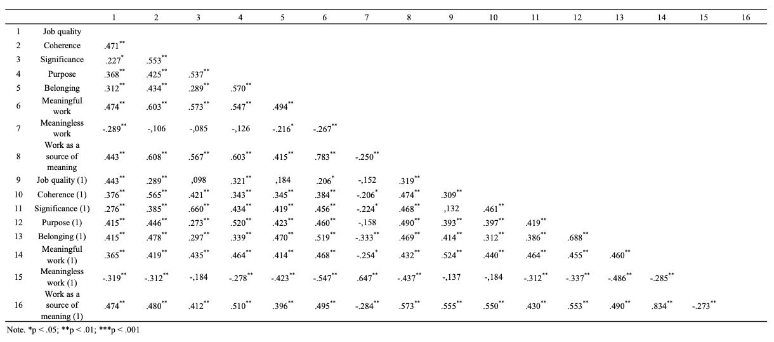

3.2 Associations among the variables
To test the hypothesis, we ran a correlation analysis (Table 1). We discovered that our findings are consistent with what research is investigating. More specifically, we found that job quality is significantly related to meaningful work, in terms of coherence (r = .471, p < .01), significance (r = .227, p < .01), purpose (r = .368, p < .01) and belonging (r = .312, p < .01), and lower reported levels of meaningless work (r = -.289, p < .01). This is true both in time 1 and in time 2 of measuring, even if a few points are different for first and second measurements. Moreover, we found that job quality is significantly related with work as a source of meaning (r = .433, p < .01). Therefore, from the correlation analyses we can conclude that the hypothesis we wanted to test was largely confirmed by obtained data: post-covid job quality affects the level of meaning at work, and the second measurement confirms the results of the first one.

3.3 Model testing
Given the correlations reported above, we verified the two mediation models reported in Figure 1 using SEM. Therefore, the observed variables comprised four latent variables, namely, Post-covid Job Quality, Meaningful work, Meaningless work and Work as a source of meaning. Before verifying the hypotheses of the mediation role of Meaningful and Meaningless work in Time 1 and 2, hypotheses of the association between Post-covid Job Quality and Work as a source of meaning were tested, in both Time 1 and 2. Post-covid Job Quality positively predicted the level of Work as a source of meaning (X²(100) = 573.852, p < .001; CFI=0.87; TLI=0.955; RMSEA=0.043; SRMR=0.019) with a standardized coefficient effect equal to β = .30 in Time 1, and β = .26 in Time 2. Given this verification, we verified the mediation role of Meaning and Meaningless work. We analyzed the mediation role of Meaningful and Meaningless work within the association between Post-covid Job Quality facets (i.e., Coherence, Significance, Purpose and Belonging) and Work as a source of meaning. Meaningful work positively predicted Work as a source of meaning in both Time 1 (β = .70) and Time 2 (β = .73). Thus, the hypothesis of the mediating role of Meaningful work on the association between Post-covid Job Quality and Work a source of meaning, was confirmed. No significant changes within Time 1 and 2 were found.

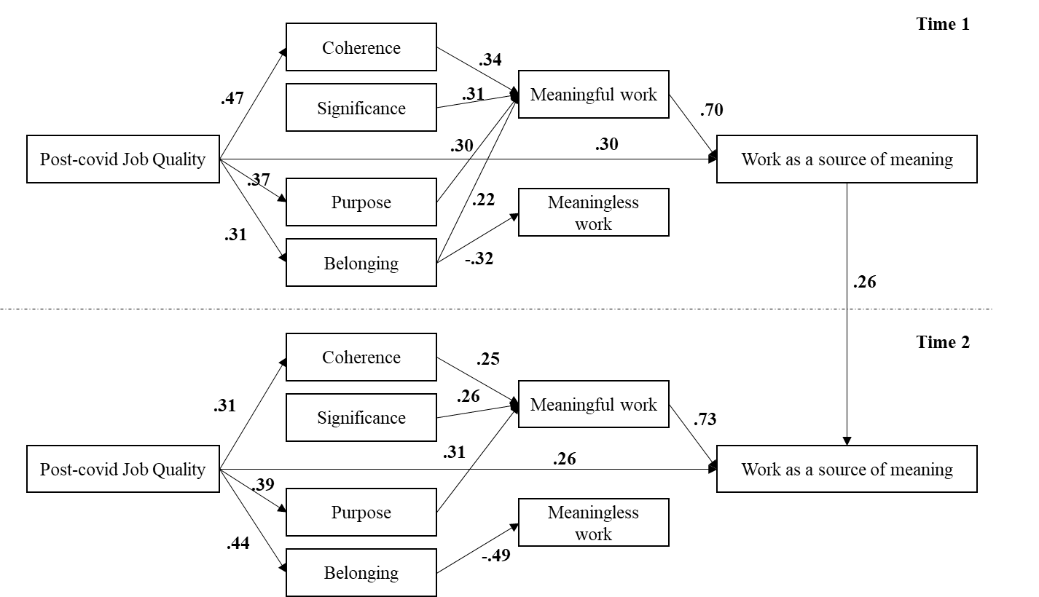

4. Discussion

It is therefore no coincidence that the current critical reflections focus on questions concerning the challenges for the meaning of work following the health and economic crises of recent months. In particular, the debate focuses on how in face of the demands of work, responsibilities and working hours, employees can lose themselves in terms of meaning at work. Hence, it is central how, in face of new working arrangements and conditions, organizations act to guarantee and protect work from the point of view of the quality of work and the degree to which work can be a source of meaning. This study attempts to show how changes in terms of work arrangements and perceptions of job security can influence perceptions of meaning at work. It reveals how the quality of work as measured by organizational safety and training resources affects the level of meaning at work. Given the challenge that organizations are called to face due to the changes caused by the covid-19 pandemic, in this contribution we tested differences in employees’ job quality perceptions (in terms of training, safety and communication) and meaningful work (in terms of purpose, sense of belonging, sense of coherence, and significance). This effort was necessary to provide organizations some insight that serve as basis on which conducting new training interventions. Such interventions can be capable to ensure job quality and meaningful work in the new (post-pandemic) organizational contexts.

References
Ahmed, U., Majid, A., Al-Aali, L., & Mozammel, S. (2019). Can meaningful work really moderate the relationship between supervisor support, coworker support and work Engagement? Management Science Letters, 9(2), 229-242.
Allan, B. A., Batz-Barbarich, C., Sterling, H. M., & Tay, L. (2019). Outcomes of meaningful work: A meta‐analysis. Journal of Management Studies, 56(3), 500-528.
Bailey, C., Lips‐Wiersma, M., Madden, A., Yeoman, R., Thompson, M., & Chalofsky, N. (2019). The five paradoxes of meaningful work: Introduction to the special issue ‘meaningful work: Prospects for the 21st century’. Journal of Management Studies, 56(3), 481-499.
Barbieri, B., Balia, S., Sulis, I., Cois, E., Cabras, C., Atzara, S., & De Simone, S. (2021). Don’t Call It Smart: Working from Home during the Pandemic Crisis. Frontiers in psychology, 12.
Bolisani, E., Cegarra Navarro, J. G., & Garcia-Perez, A. (2021). Managing counter-knowledge in the context of a pandemic: challenges for scientific institutions and policymakers. Knowledge Management Research & Practice, 1-8.
Cellini, M., Pisacane, L., Crescimbene, M., & Di Felice, F. (2021). Exploring Employee Perceptions towards Smart Working during the COVID-19 Pandemic: a Comparative Analysis of Two Italian Public Research Organizations. Public Organization Review, 1-19.
Correia, I., & Almeida, A. E. (2020). Organizational justice, professional identification, empathy, and meaningful work during COVID-19 pandemic: Are they burnout protectors in physicians and nurses?. Frontiers in Psychology, 11, 3545.
Gómez-Salgado, J., Domínguez-Salas, S., Romero-Martín, M., Ortega-Moreno, M., García-Iglesias, J. J., & Ruiz-Frutos, C. (2020). Sense of coherence and psychological distress among healthcare workers during the COVID-19 pandemic in Spain. Sustainability, 12(17), 6855.
Laaleh Al-Aali, A. O., & Ahmed, U. (2021). Addressing the issue of meaningful work during covid-19 through ldw model: An empirical study. Elementary Education Online, 20(4), 1791-1799.
Schnell, T., & Hoffmann, C. (2020). ME-Work: Development and Validation of a Modular Meaning in Work Inventory. Frontiers in Psychology, 11, 3405.
Tommasi, F., Ceschi, A., & Sartori, R. (2020). Viewing Meaningful Work Through the Lens of Time. Frontiers in Psychology, 11.
Tommasi, F., Sartori, R., Ceschi, A. & Schnell, T. (2021). The Meaning in Work Inventory: Validation of the Italian version and its association with sociodemographic variables. Applied Psychology Bulletin, 69(291), 17-36.

