UNIVERSITA’ DEGLI STUDI DI VERONA

DEPARTMENT OF

Neurosciences, Biomedicine, and Movement Sciences

GRADUATE SCHOOL OF

Life and Health Sciences

DOCTORAL PROGRAM IN

Neuroscience, Psychological and Psychiatric Sciences, and Movement Sciences

Cycle / year (1° year of attendance) 32°

TITLE OF THE DOCTORAL THESIS

“Neurofilament light chain levels in patients with antibodies to myelin oligodendrocyte glycoprotein (MOG-Abs)”

S.S.D. MED/26 Neurologia

Coordinator: Prof. G. Zanusso

Tutor: Dr. A. Gajofatto

Doctoral Student: Dott.ssa S. Mariotto

Sommario

Obiettivo dello studio: misurare i valori di neurofilamenti (NfL) sierici nei pazienti con anticorpi anti-MOG in rapporto alle loro caratteristiche cliniche e strumentali e monitore le variazioni dei livelli di NfL nel singolo paziente nel corso del tempo.
Premesse: I NfL sono un marcatore di danno assonale ed aumentano nel siero e nel liquor dei pazienti con svariate patologie neurologiche, in correlazione all’attività clinica e radiologica di malattia. Sulla base di questi presupposti, i NfL potrebbero essere un biomarcatore utile per monitorare l’andamento clinico nei pazienti con patologie infiammatorie associate ad anticorpi anti-MOG, il cui decorso clinico è altamente variabile e difficilmente prevedibile.
Disegno dello studio e metodi: abbiamo raccolto i sieri e, quando disponibili (n=17) i liquor di 63 pazienti risultati consecutivamente positivi per anticorpi anti-MOG analizzati presso il Laboratorio di Neuropatologia dell’Università di Verona tra marzo 2015 ed agosto 2019 mediante un test basato su colture cellulari in vivo. In tutti i campioni abbiamo misurato i valori di NfL utilizzando la tecnologia Quanterix, SIMOA (SR-X analyser). Inoltre, abbiamo testato 60 campioni di 28 pazienti raccolti nel corso del follow-up. Per tutti i casi inclusi nello studio abbiamo raccolto i dati clinici e radiologici ottenuti al momento del prelievo e all’ultima valutazione.
Risultati: abbiamo riscontrato una moderata correlazione tra i valori di NfL sierici e l’età al momento del prelievo, con valori maggiori riscontrati nei pazienti più anziani (r_{s}=0.41, p < 0.001). Abbiamo inoltre osservato una moderata correlazione tra i valori di NfL misurati nel siero e nel CSF del medesimo paziente (r_{s}=0.42, p =0.09), senza però una chiara correlazione tra valori di NfL sierici e titolo anticorpale anti-MOG (r_{s}=0.15, p = 0.11). Inoltre, i pazienti con positività esclusivamente liquorali per gli anticorpi anti-MOG avevano valori maggiori di NfL liquorali. Dato interessante è risultato la correlazione tra valori di NfL e la disabilità clinica al momento del prelievo (r_{s}=0.43, p < 0.001). Tuttavia, i valori di NfL non permettevano di differenziare i pazienti in base alla gravità del quadro radiologico o all’andamento clinico. I NfL risultavano diminuiti (n=30) o stabili (n=23) nel corso del follow-up se paragonati alla misurazione iniziale, indipendentemente dalla presenza o meno di una ricaduta in atto, come a riflettere una riduzione della disabilità rispetto all’esordio. Infine, i pazienti con attività clinica e radiologica di malattia avevano valori di NfL tendenzialmente, seppur in maniera non statisticamente significativa, maggiori.
Conclusioni: i NfL potrebbero avere un ruolo come biomarcatore di disabilità nei pazienti con anticorpi anti-MOG, che andrà chiarito in futuri studi prospettici.

Abstract

Objective: to assess neurofilament light chain (NfL) concentration in MOG-Ab-positive patients according to clinical/paraclinical characteristics and to evaluate intraindividual changes over time.
Background: NfL is a marker of axonal injury, increased in serum/CSF of patients with several neurological disorders in correlation with clinical and radiological activity. As a consequence, NfL could be a useful biomarker to monitor disease activity in MOG-Ab-related inflammatory conditions, where the course is highly heterogeneous and unpredictable.
Design/methods: sera and available (n=17) CSF samples of 63 consecutive MOG-Ab-positive patients tested at the Neuropathology Laboratory, University of Verona, between March 2015-August 2019 using a live cell-based assay were analysed for NfL using SIMOA Nf-light kit (SR-X analyser). Sixty follow-up samples of 28 patients were also analysed. Clinical and radiological data at sampling and at last follow-up were collected in each case.
Results: we observed a moderate correlation between serum NfL values and age at sampling, with higher levels detected in older subjects (r_{s}=0.41, p < 0.001). In addition, a moderate correlation was noted between paired serum/CSF NfL values (r_{s}=0.42, p =0.09), but not between serum MOG-Ab titer and serum NfL levels (r_{s}=0.15, p = 0.11). CSF only MOG-Ab positive cases had higher CSF NfL levels in comparison with seropositive ones. Interestingly, NfL values correlated with disability at sampling (r_{s}=0.43, p < 0.001) but did not differentiate monophasic and relapsing cases. When analyzing follow-up samples, NfL levels decreased (n=30) or remain stable (n=23) in comparison with first measurement in most cases, including those on relapse, in parallel with a decrease of clinical disability in comparison with first event EDSS. Finally, although radiologically and clinically active patients tend to have higher NfL values in comparison with inactive ones, the difference between the groups was not significant.
Conclusions: The role of serum NfL as a potential biomarker of neurological disability in MOG-Ab positive patients needs further clarification in in prospective studies.

INDEX
- Introduction pg.6
  - Inflammatory demyelinating diseases pg.6
1.1.1 Multiple sclerosis (MS) pg.8
1.1.2 Neuromyelitis optica spectrum disorders (NMOSD) pg.11
1.1.3 Acute disseminated encephalomyelitis (ADEM) pg.15
1.1.4 Acute transverse myelitis (ATM) pg.16
1.1.5 Optic neuritis (ON) pg.18
  - Antibodies to MOG pg.20
1.2.1 General considerations and diagnostic techniques pg.20
1.2.2. Clinical and radiological characteristics pg.23
1.2.3 Treatment strategies pg.29
1.2.4 Neuropathological aspects pg.30
1.2.5 Pathogenesis pg.30
  - Neurofilament light chain (NfL) pg.31
1.3.1 General considerations and diagnostic techniques pg.31
1.3.2 NfL in patients with MS pg.32
1.3.3 NfL in NMOSD and related conditions pg.32
- Objectives of the study pg.35
- Materials and Methods pg.36
3.1 Study subjects pg.36
3.2 Clinical/radiological data and diagnosis pg.36
3.3 AQP4-Abs and MOG-Abs analysis pg.37
3.4. Neurofilament analysis pg.38
3.5 Statistical analysis pg.38
- Results pg.39
4.1 Demographic, clinical, and paraclinical data of MOG-Abs positive cases pg.39
4.2 Correlation between clinical/paraclinical characteristics and NfL values pg.47
4.3 Significance of monitoring NfL values over time in MOG-Abs positive patients pg.50
- Discussion pg.52
- Conclusions pg.54
- References pg.55

1 Introduction
  - Inflammatory demyelinating diseases
Inflammatory demyelinating diseases (IDD) represent a spectrum of heterogeneous disorders affecting the central nervous system (CNS). Multiple sclerosis (MS) is classified as a chronic, immune-mediated, demyelinating disorder and it is the most well-known disease of this group. Neuromyelitis optica spectrum disorders (NMOSD), which preferentially involve the spinal cord and the optic nerve, and acute disseminated encephalomyelitis (ADEM), a typically monophasic disease of children, are also part of this spectrum. Other acute inflammatory conditions including idiopathic optic neuritis (ON) and acute transverse myelitis (ATM) also enter in the differential diagnosis. A major discovery in this field was the association between NMOSD and serum aquaporin 4 IgG (AQP4-IgG), confirming that it is a different disease from MS and needs distinct treatment. On the other hand, the association between myelin oligodendrocyte glycoprotein (MOG-Abs) and ADEM, NMOSD and partial form of the disease also clarified the final diagnosis in many conditions previously classified as “idiopathic”. The great overlap of clinical and radiological features among the wide spectrum of IDD may lead to an erroneous diagnosis and subsequent unwarranted treatments. The identification of specific antibodies associated with these conditions is of utmost practical importance and helps clinicians in the difficult process of the correct disease identification and proper treatment choices.

Figure 1. Differential diagnosis of MS.¹

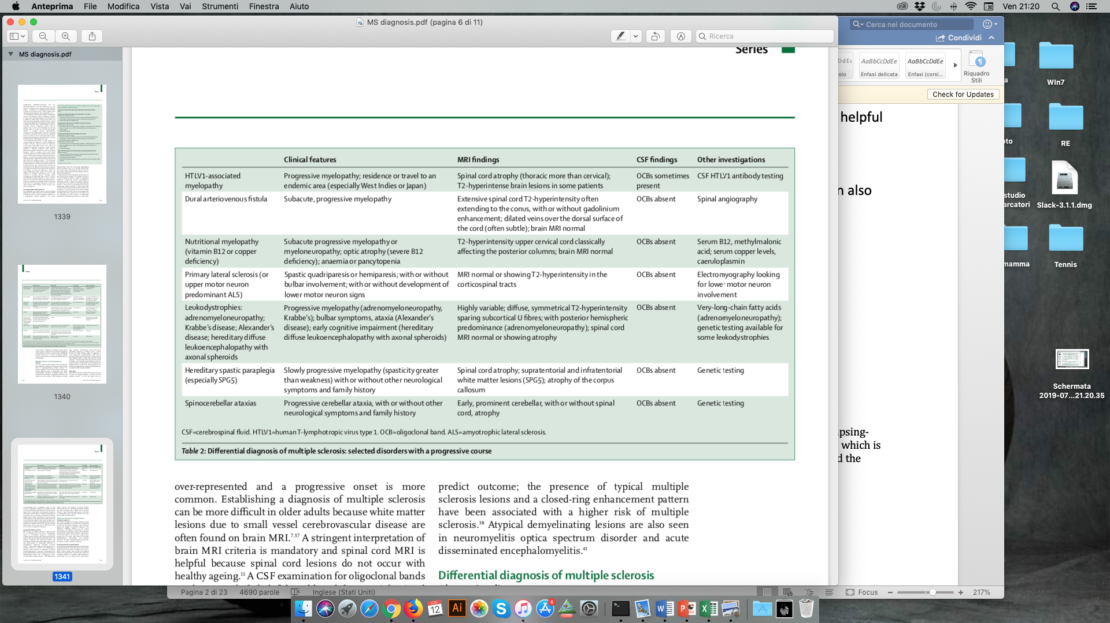

1.1.1 Multiple sclerosis (MS)
MS is a chronic, immune-mediated, demyelinating disorder of the CNS which can present with changes in sensation, mobility, balance, sphincter function, vision, and cognition. The disease course is highly variable and classified as either relapsing-remitting (85-90%) or primary progressive (10-15%), and patients can develop relevant disability over the disease course.² Relapses are defined as episodes of neurological dysfunction lasting at least 24 hours in the absence of fever or infection, followed by periods of remission,³ which can be only partial.⁴ An insidious, slowly progressive increase in neurological disability over time, usually without relapses, characterizes primary progressive MS. A progressive course with a gradual increase in disability with or without relapses can also follow a relapsing-remitting course (secondary progressive MS).⁴ Different diagnostic criteria have been proposed over time, including the most recently revised ones.⁵ The value of these criteria, which seems to allow a more sensitive but less specific diagnosis of MS, is still under investigation.
Figure 2. The 2017 criteria for diagnose MS.⁵
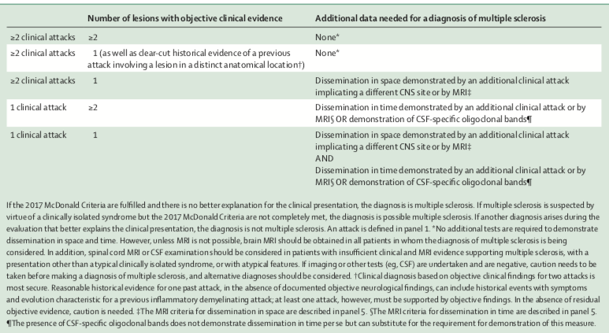

Figure 3. 2017 revisions to the McDonald diagnostic criteria for MS.⁵
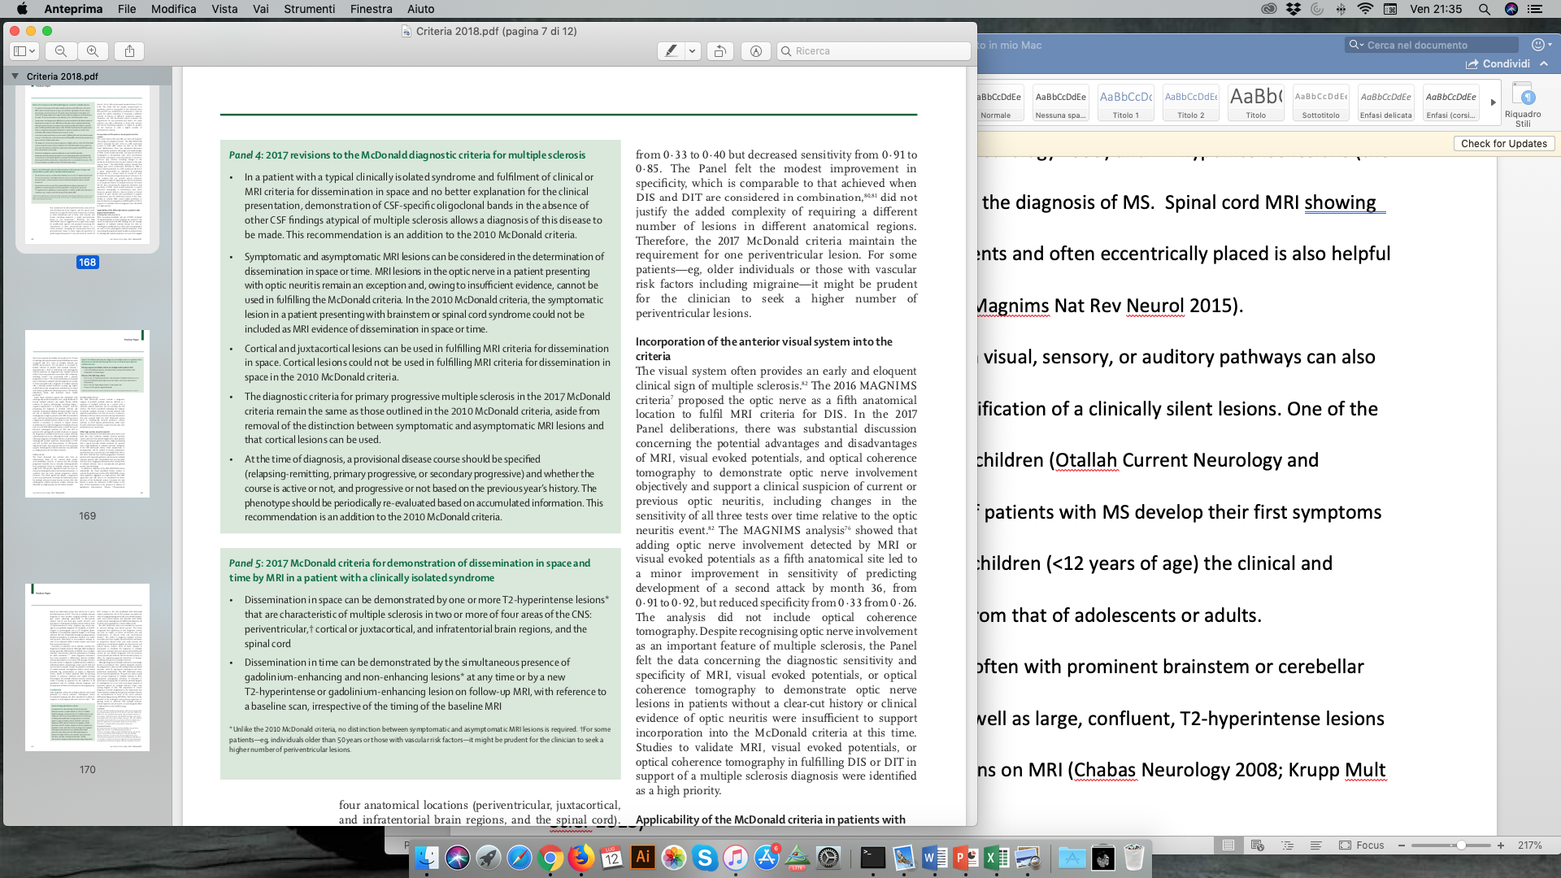

Figure 4. 2017 criteria for diagnose MS in patients with a primary progressive course.⁵
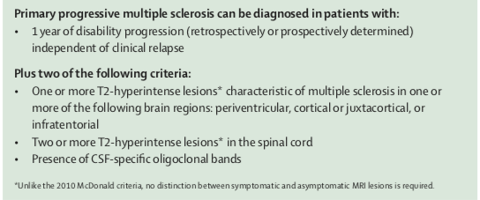

Figure 5. 2017 criteria for the demonstration of dissemination in space and time by MRI.⁵
Brain MRI, which typically shows multifocal T2-hyperintense white matter lesions in characteristic locations (periventricular -including the corpus callosum-, juxtacortical, and infratentorial regions⁶ and T1-hypointense lesions (the so-called black holes) gives a great contribution in the diagnosis of MS. Spinal cord MRI showing lesions extended over one or two vertebral segments and often eccentrically placed is also helpful in the differential diagnosis with NMOSD.⁷ Neurophysiological testing of evoked potentials in visual, sensory, or auditory pathways can also provide supportive evidence of MS, through identification of a clinically silent lesions. In addition, examination of cerebrospinal fluid (CSF) can provide supportive evidence when showing a normal or mildly raised white cell count (predominantly lymphocytes) and protein content (usually <1 g/L), a raised IgG index, and CSF restricted oligoclonal bands.⁵ One of the main controversy rises in the diagnosis of MS in children.⁸ Actually, up to 5% of patients with MS develop their first symptoms in childhood.⁹ However, in younger children (<12 years of age) the clinical and radiological presentation of MS can be different from that of adolescents or adults. Encephalopathy, multifocal neurological deficits (often with prominent brainstem or cerebellar involvement), and seizures are more common, as well as large, confluent, T2-hyperintense lesions that show remarkable resolution on follow-up MRI.^{9,10} In both children and adults, in particular when the presentation is not typical and red flags occur, interpretation and integration of the history, physical examination, and results of imaging and laboratory testing by expert clinicians remain fundamental in making a reliable diagnosis. Many different drugs have been demonstrated to modify the course of MS, reducing the likelihood of the development of new white-matter lesions, clinical relapses, and stepwise accumulation of disability, so that an early and accurate diagnosis of MS is essential. However, despite the efforts to revise diagnostic criteria and facilitate the differential diagnosis, misdiagnosis of MS remains an issue in clinical practice.
1.1.2 Neuromyelitis optica spectrum disorders (NMOSD)
NMOSD is an inflammatory CNS syndrome characterized by a preferential involvement of the optic nerve and spinal cord. NMOSD generally affects young adults, with a predominance in females (68-88%).¹¹ Rare cases of disease onset in elderly have been also described and should always rise the suspicion of a paraneoplastic origin.¹² On the other hand, NMOSD can occur also in children, were the distinction from other demyelinating diseases is even more challenging.¹³ The most typical presentations of NMOSD include acute (usually bilateral) optic neuritis with severe visual acuity impairment, and longitudinally extensive transverse myelitis, typically presenting with severe symptoms including paraplegia, bowel/bladder dysfunctions, and sensory loss.¹⁴⁻¹⁶ However, short-segment myelitis does not exclude NMOSD diagnosis.¹⁷ The course is usually relapsing (90%), with increasing burden of impairment,¹⁸ influenced in particular by onset age, onset phenotype, and ethnicity.¹⁹ NMOSD diagnosis is currently based on clinical, neuroimaging and laboratory features.²⁰

Figure 6. NMOSD diagnostic criteria for adult patients.²⁰
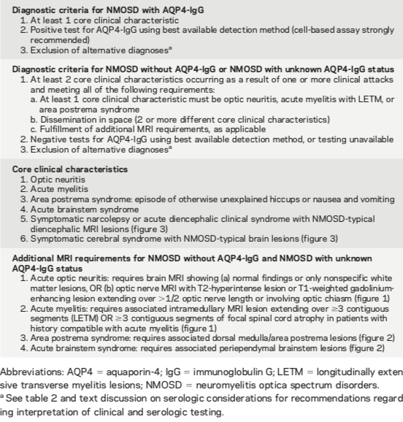

Figure 7. Neuroimaging characteristics of NMOSD.²⁰
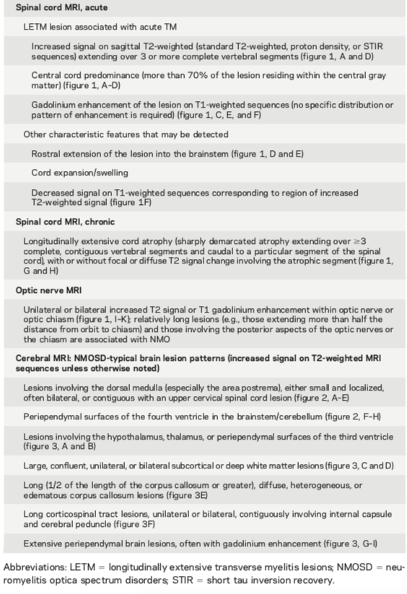

Figure 8. Red flags: findings atypical for NMOSD.²⁰
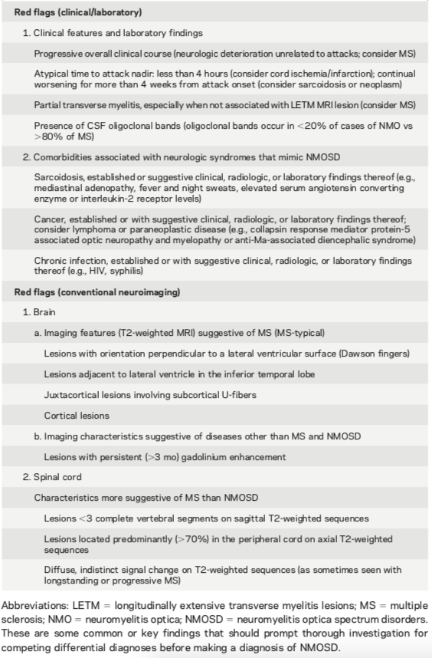

In comparison with previously proposed diagnostic criteria, the novel and updated criteria have adopted the broader term of NMO Spectrum Disorders (NMOSD) to include patients with limited or uncommon manifestations. Supportive criteria include slight pleocytosis (in particular high level of neutrophils or eosinophils), slight increase of protein content, and absence of CSF restricted oligoclonal bands. More importantly, recent criteria classified NMOSD into two subtypes based on serum AQP4-IgG status, giving a major diagnostic role to the detection of AQP4-Abs.²⁰ These antibodies target aquaporin-4, an integral protein of astrocytes and ependymal in the nervous system. AQP4-Abs have pathogenic potential and are highly sensitive (73%) and specific (91%) for this disease.²¹⁻²³ AQP4-Abs can be detected in sera of most patients (68% – 91%),²⁴ while CSF testing is not routinely recommended in seronegative cases.²⁵ However, few cases with restricted CSF AQP4-Abs positivity have been described, supporting the measure of CSF AQP4-Abs if NMOSD is strongly suspected and serum is negative.²⁶ It has also to be considered that the use of different diagnostic techniques has a great impact on AQP4-Abs detection. AQP4 encodes two distinct mRNAs with different translation initiating methionines, which results in two heterotetramers different in the 23 amino acids in the N terminus of the protein: the full length M1 and the M23 isoform.²⁷ Antibody binding and complement activation seem to be enhanced in presence of the M23 isoform, which clusters at the cell surface to form orthogonal arrays of particles.^{28,29} M23 AQP4 could be the initial and major target antigen for circulating autoantibodies, whereas antibodies to M1 AQP4 could be produced during disease course in most severe cases.³⁰ Both isoforms are usually observed in samples obtained at onset, with decrease of both M1 and M23 titers with successive relapses and disappearance of M1 in some cases in course of immunosuppressive treatment.³¹ All together, these data explain the different sensitivity and specificity of the available diagnostic techniques. The use of live cells-bases assay (CBA) transfected with M23 isoform of AQP4 emerged as the optimal sensitive test, in particular in low titer cases.^{30,32,33} Commercially available CBA transfected with M1 isoform of AQP4 also perform well, while immunohistochemistry on fixed tissue sections is less sensitive.³⁴ False positive results have also to be taken into account, particularly by M1-ELISA and M23-FACS and can be due to ANA positivity, hypergammaglobulinemia, avid nonspecific IgG binding of IgG to M23-AQP4 or interaction of monoclonal antibodies therapies such as Natalizumab with CBA technique.³⁵ In addition, how the AQP4-M1 CDS is cloned, the position of the fluorescent tag of the AQP4-M23, as well as the use of flow cytometry compared to CBA can influence assay performance.³³ These observations are of utmost clinical importance and highly influence diagnostic accuracy and administration of correct treatments.
Steroids, associated with plasma exchange (PE) in more severe cases, are standard treatments for acute attack, and short treatment delay is a strong predictor of outcome.³⁶ Despite the absence of randomized clinical trials, immunosuppressive drugs are then administered in the long-term, to control attack severity and prevent relapses.^{37,38} Novel drugs including Tocilizumab, a human monoclonal antibody directed against the IL-6 receptor,³⁹ Eculizumab, a humanized monoclonal antibody that neutralizes the complement protein C5,⁴⁰ Inebilizumab, an anti-CD19 B-cell depleting antibody,⁴¹ and Aquaporumab, a recombinant human monoclonal antibody that tightly binds AQP4 and blocks the activation of the complement cascade,⁴² are currently under investigations for the treatment of treatment-refractory cases. In particular, two recent double-blind, placebo-control trials demonstrated that Eculizumab⁴⁰ and Inebilizumab⁴¹ significantly reduce risk of relapse in comparison with placebo, supporting their application as evidence-based treatments in patients with NMOSD.
1.1.3 Acute disseminated encephalomyelitis (ADEM)
ADEM is defined as an acute multifocal demyelinating disease of the CNS. Although typically encountered in children following a viral/bacterial infection or vaccination, it can also occur in adults.⁴³ Clinical manifestations of ADEM can be pleotropic according to the initial CNS site affected by the inflammation, and include a variable extent of encephalopathy, cranial nerve palsies, ataxia, hemiparesis, myelopathy, and optic neuritis.⁴⁴ CSF analysis typically shows mild pleocytosis in absence of oligoclonal bands.⁴⁵ One of the main supportive features is brain MRI, typically showing several, large, contrast (from complete to ring-shaped, open ring, gyral, and nodular) or non-contrast enhancing lesions involving both the white and gray matter (in particular cerebral cortices, thalamus, basal ganglia, brainstem, and cerebellum). Rarely, large solitary lesions can be seen in the brain, often resembling neoplasm, and in these cases the correct diagnosis needs to be confirmed by biopsy. In addition, in 11-28% of cases spinal cord is affected, usually showing large and edematous lesions. Repeated MRI, obtained 6 months after the initial episode, should show resolving lesions and no evidence of new ones.
Figure 9. Criteria proposed by Krupp et al. for pediatric ADEM (all requited).⁹
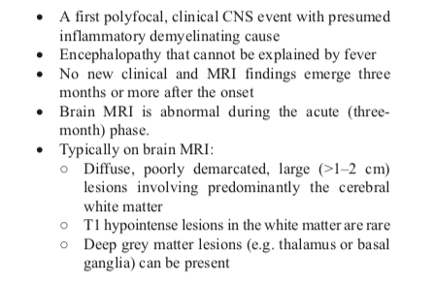
ADEM course is monophasic in most cases; however, relapsing ADEM occurs occasionally and this may pose a diagnostic challenge for distinguishing it from other IDD.⁴⁴ The prognosis of ADEM is generally good, but severe neurologic sequelae after ADEM are occasionally seen.⁹ Treatment choices largely influence outcome. High-dose steroids followed by slow steroid tapering is recommended, while PE/intravenous immunoglobulins (IVIG) or cyclophosphamide are considered as third-line agents in refractory cases.⁴⁴

Figure 10. Diagnostic criteria for definite ADEM proposed by Graus et al.⁴⁶
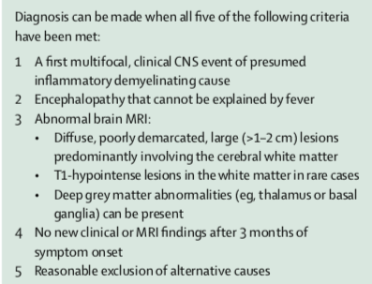

1.1.4 Acute transverse myelitis (ATM)
ATM is an acute inflammatory neurological disorder of the spinal cord causing bilateral motor and/or sensory impairment with or without sphincter dysfunction. The etiopathogenesis is heterogeneous, as well as the final outcome. Idiopathic ATM should be diagnosed in presence of a clearly defined sensory level, evidence of inflammation by CSF or MRI gadolinium enhancement, and clinical progression to nadir between 4 hours and 21 days in absence of alternative diagnoses.⁴⁷

Figure 11. Criteria for idiopathic ATM ⁴⁷

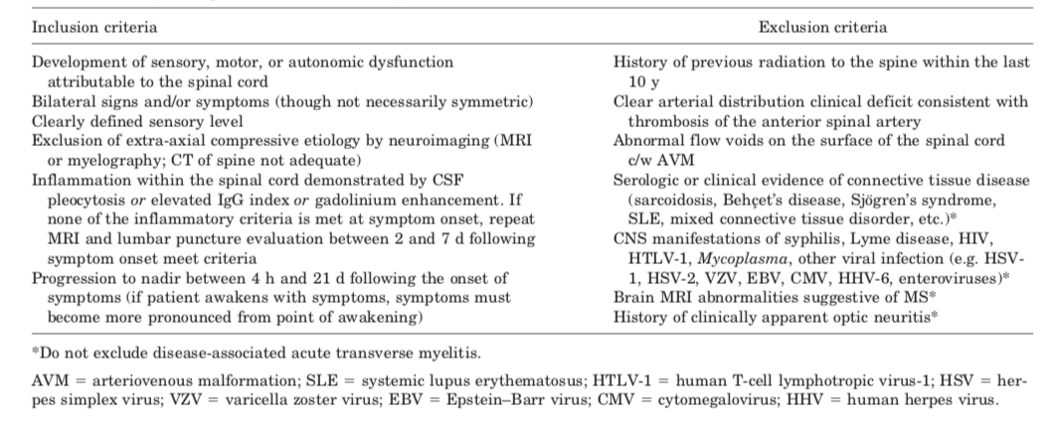

On the other hand, disease-associated ATM can have an autoimmune, vascular, metabolic, paraneoplastic, or neoplastic etiology and require a rapid diagnosis to establish a correct treatment.⁴⁸ The recent discovery of novel antibodies linked with inflammatory processes, together with the correct examination of the medical history, lesions distribution on MRI, and analysis of the temporal profile of symptoms, improved diagnostic accuracy.^{49,50} However, despite the application of the most advanced diagnostic, idiopathic forms of ATM are still common and represent a diagnostic challenge.

Figure 12. Differential diagnosis of ATM.⁵¹
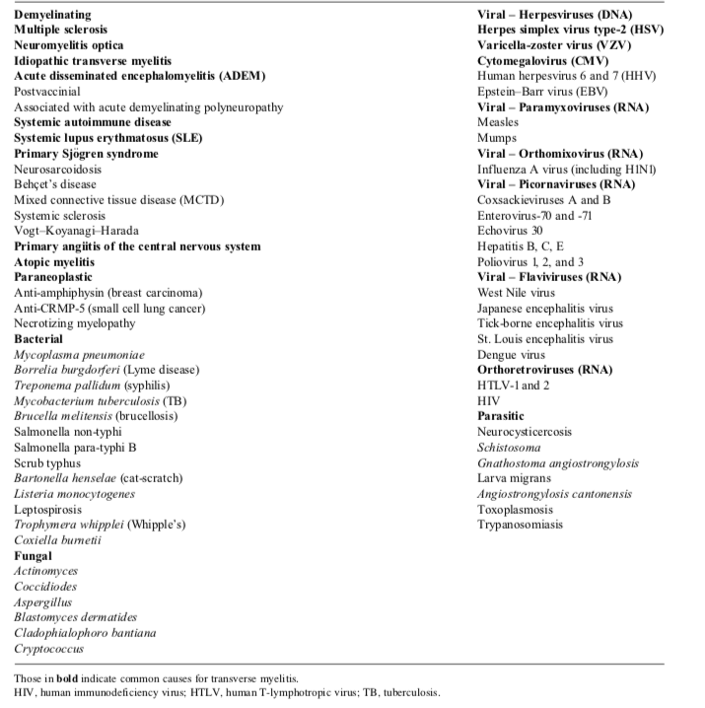

1.1.5 Optic neuritis (ON)
ON is characterized by inflammation of the optic nerve and can be associated with MS, NMOSD, and chronic relapsing inflammatory optic neuropathy (CRION).⁵² The risk of severe visual impairment is high, so that these different entities must be recognized and correctly treated.⁵³

Figure 13. Definitions and diagnosis of ON.⁵³

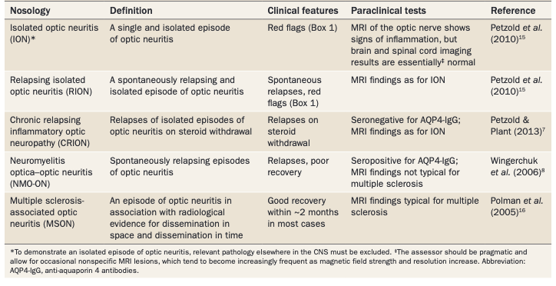

The most common clinical presentation of ON consists of (peri)ocular pain, often retrobulbar, which frequently precedes loss of vision and is typically associated with dyschromatopsia. Positive phenomena such as phosphenes and scintillations can also occur. Accurate measurement of best corrected high contrast visual acuity, retinal examination, examination of pain during eye movement, as well as Retinal Optical Coherence tomography (OCT), which permits accurate documentation of changes in thickness of retinal layers, represent the standard care protocol.
MRI of the optic nerve is complementary to brain MRI and frequently demonstrates optic nerve inflammation (occasionally extending to the chiasm and the optic tracts), swelling of the affected segment or thinning of the nerve. Contrast enhancement can be also observed.
Serum/CSF analyses as well as electrodiagnostic tests (i.e. visual evoked potentials, standard electroretinogram and a pattern electroretinogram) have a role in the investigation of atypical presentations of ON.⁵³ Similar to what have been reported for patients presenting with myelitis, the discovery of novel antibodies significantly reduced the number of “idiopathic” forms of ON. However, the group of “idiopathic” cases is still well represented and constitutes a challenge for clinicians, since it is usually characterized by a poor visual outcome and a high rate of recurrences (56.5%).⁵⁴

  - Antibodies to MOG
1.2.1 General considerations and diagnostic techniques
MOG is a highly conserved member of the immunoglobulin superfamily which gene maps to the region encoding the major histocompatibility complex in both humans and rodents.⁵⁵ This 26-28 kDA glycoprotein is exclusively expressed in the CNS, and in particular in the surface of myelin sheath and in the plasma membrane of oligodendrocytes.⁵⁶

Figure 14. Structures and functions of MOG isoforms.⁵⁷
Amino acids outside the N-terminal domain determine the primary structure and membrane location of the MOG isoform, while inclusion of different exons determines the specific isoform. The extracellular domain mediates biological functions including recognition of IgG, complement, and Rubella virus.

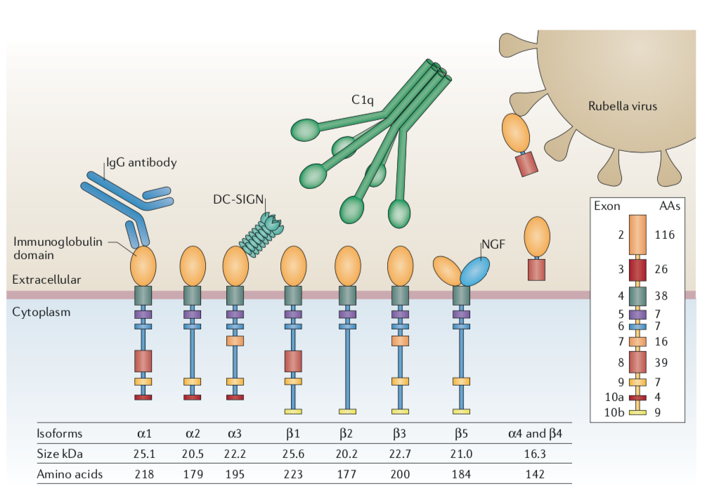

The role of MOG is not completely established. However, some evidences support its action as a cellular receptor, regulator of microtubule stability, cell adhesion molecule, and as a mediator of interaction between myelin and the immune system.⁵⁸ MOG was first identified as a target of demyelinating antibodies in guinea pigs⁵⁹ and, for its specific location and properties, has then been used in animal models of demyelinating autoimmunity. In particular, MOG induces strong pathogenic T cell responses in many strains of laboratory animals and it is used as one of the major encephalitogenic antigens able to induce the immunization of mice and elicit a demyelinating immune response in numerous experimental models of inflammatory demyelinating diseases. These include also the experimental autoimmune encephalomyelitis (EAE), a mice model which recapitulate the immune components of human MS.^{60,61} In addition, the encephalitogenic properties of MOG are linked to the induction of antibody responses, which have been demonstrated to directly promote CNS demyelination, a hallmark neuropathological feature in disorders such as MS. As a natural consequence, in an attempt to translate animal models results to humans, antibodies to MOG (MOG-Abs) have been investigated in serum and CSF of patients with CNS inflammatory conditions and initially proposed as a possible marker of MS.⁶² However, subsequent studies provided different evidence and demonstrated that MOG-Abs are not specific for MS.⁶³ More recently, a clear explanation of these discrepancies and disappointing results have been provided. In both animal models and humans, MOG-Abs are directed against the conformational and glycosylated form of MOG, so that the detection of antibodies to native and conformationally intact form of the protein is mandatory. The first studies, which detected MOG-Abs in MS patients, analysed MOG-Abs using enzyme-linked immunosorbent assay (ELISA) or immunoblotting assays. These techniques detect antibodies to linear / denaturated MOG and, as a consequence, identify antibodies against non-native epitopes. Using ELISA/immunoblotting, MOG-Abs were detected in a subgroup of MS patients, but frequently occurred also in other disorders and in the general population, confirming the inconsistence of these methods for the detection of MOG-Abs. Kevin O’ Connor first suggested the clinical utility of testing MOG-Abs using a natively-folded MOG substrate.⁶⁴ The development of cell-based assays (CBA) using transfected cells and a full-length conformationally intact MOG construct consented the reliable detection of antibodies against native correctly folded and glycosylated MOG. With this technique, the recombinant antigen is expressed in its natural conformation on the surface of human embryonic kidney cells (HEK) and antibodies present in serum/CSF interact with the extracellular surface of proteins. This method, together with the use of higher cut-off values or selective (IgG1) secondary antibodies, improved assay sensitivity/specificity and allowed the identification of the clinical phenotype associated with MOG-Abs. However, different methods in term of MOG expression vectors, cell lines, read-out system, secondary antibodies, and cut-off are currently used to measure MOG-Abs. In addition, Euroimmun has developed a fixed CBA, which however seems a less reliable indicator of MOG-Abs positivity.⁶⁵ Major efforts have already been made to compare the various MOG antibody assays, but a large multicenter comparison study is now needed and planned for the standardization of assays. Current recommendations include the analysis of MOG-Abs using CBA with recombinant antigen expressed in its natural conformation, the use of IgG1-specific secondary antibodies, and the use of a second method as confirmation.

Figure 15. Expert recommendations for MOG-Abs testing.⁵⁷
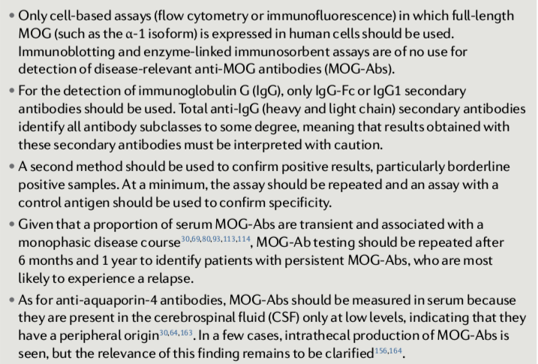

In addition, experts recommend the measure of MOG-Abs in serum only.⁵⁷ This latter recommendation is based on a single report by Jarius and colleagues, who analysed 17 CSF samples of patients with serum MOG-Abs and 17 CSF samples of controls with MS. The authors observed CSF MOG-Abs positivity in 12 MOG-Abs seropositive cases, while they did not detect intrathecal antibodies in any control. In addition, an antigen-specific MOG antibody index > 4 was not observed in any paired CSF/serum sample. These data suggested a predominantly extrathecal origin of CSF MOG-Abs.⁶⁶
However, isolated cases with intrathecal MOG-Abs synthesis have been previously reported.⁶⁷⁻⁷⁰ We also recently described exclusive CSF MOG-Abs positivity in 4% of an heterogenous cohort of patients with demyelinating diseases. According to our study, the percentage becomes even more relevant (7%) excluding MS patients, in which MOG-Abs seem to be of little relevance. In particular, 3 out of 7 MOG-Abs seronegative subjects with ADEM/NMOSD, which are the typical phenotypes of both children and adults with MOG-Abs, had MOG-specific CSF antibody.⁷¹ These novel data suggest that testing CSF for MOG-Abs might provide additional clues when serum analysis yields negative results and the clinical suspicion is high and may provide novel insight into the process of MOG-Abs synthesis and the biological mechanisms involved.

Table 1. Demographic, CSF, MOG-Abs and diagnosis in the cohort we analysed for paired serum and CSF MOG-Abs.⁷¹

1.2.2 Clinical and radiological characteristics
In comparison with AQP4-Abs positive NMOSD, no ethnic bias has been described in MOG-Abs positive patients, with a less dominant female to male ratio (around 1:1).^{72,73} Concomitant autoimmune disorders are uncommon in this condition (8-11% of cases), while concomitant/preceding infections (respiratory, fever, gastrointestinal signs and symptoms) are sometimes reported.^{72,74}
As previously mentioned, the first clinical phenotype associated with MOG-Abs was MS.⁶² However, the use of optimized CBA redesigned the clinical spectrum associated with MOG-Abs, which encompasses a broadening range of phenotypes, including NMOSD and partial forms of the disease (prevalent in adults) and ADEM (prevalent in children).⁷⁵⁻⁸⁴ Despite reports of isolated cases with MOG-Abs seropositivity and a final diagnosis of MS,⁸⁵ testing MOG-Abs in this condition is not recommended by experts.⁵⁷

Figure 16. Key points concerning MOG-Abs-related conditions identified by experts.⁵⁷
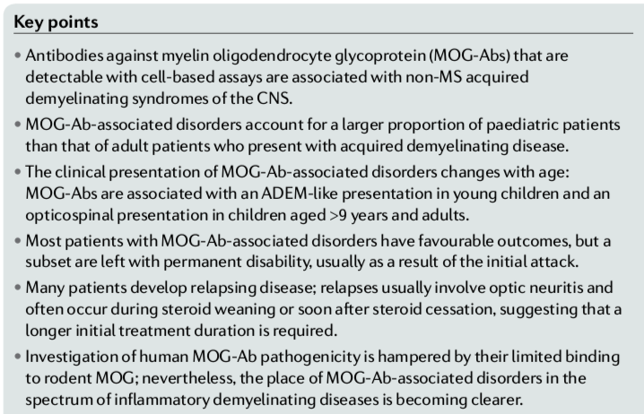

In MOG-Abs positive cases, isolated ON is the most common onset presentation (55%–64%), with simultaneous bilateral involvement in 34%–42% of patients.^{72,73,86} In contrast to AQP4-Abs positive NMOSD, the optic nerve involvement is most commonly anterior, presenting with papillitis and generally sparing chiasma and retro-chiasmatic pathways. The optic nerve is usually edematous and enlarged and optic disc oedema is observed, sometimes in association with inflammation and enhancement of the perioptic nerve sheath. Similar to AQP4-Abs positive NMOSD, optic nerve lesions usually extend along the optic nerve.⁸⁷

Figure 17. Optic nerve involvement in a MOG-Abs positive case observed in our unit, showing monolateral anterior (A) and longitudinally extensive (B) optic nerve involvement.

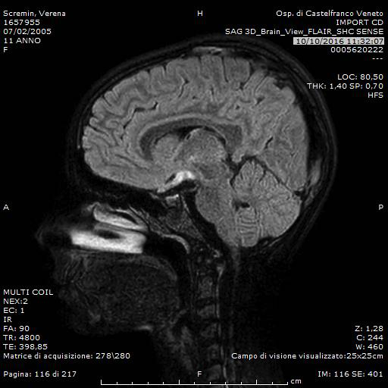
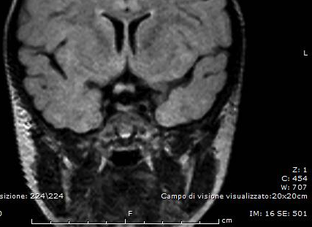
A
B

The second most common presentation is ATM (22-37%%), which typically presents as a longitudinally extensive transverse myelitis (LETM) with abnormal hyperintense T2 signal extending over 3 vertebral body segments and involving more than 50% of the axial section of the spinal cord.^{66,72} However, short transverse myelitis has also been described.^{86,88} The lower thoracic cord and conus are most commonly involved so that, in addition to sensory and motor impairment, bladder, bowel and sexual dysfunctions are common.^{66,78,89} Enhancement with blurred margins, the so called “cloud-like enhancement”, is generally observed, while well-defined nodular enhancement is less common. The most characteristic sign is however observed on axial sequences, and is characterized by a sagittal line hyperintensity surrounded by a cloudier T2-hyperintense signal associated with a H-shaped hyperintensity, the so called “H sign”.⁹⁰

Figure 18. Spinal cord involvement in a group of MOG-Abs positive case observed in our unit. Short (A) and extensive (C) spinal cord lesions can be observed, with a central predominant signal on axial sequences (B).

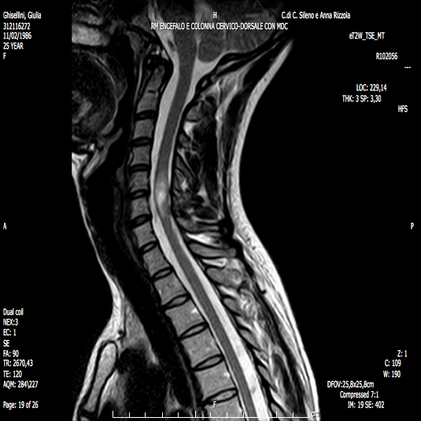
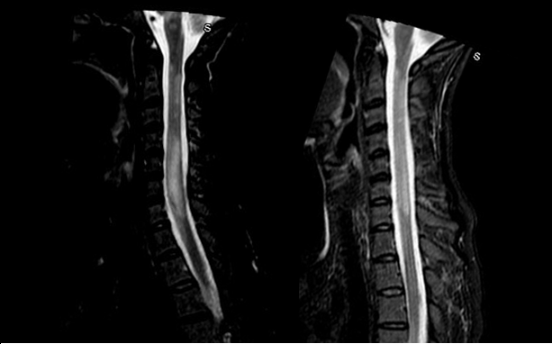
A
B
C

In both patients with MOG-Abs related ON and myelitis, brain MRI usually shows unspecific lesions, and this has been identified as one of the main features which suggests MOG-Abs testing.⁸⁸ The third most common onset (8%) is characterized by simultaneous ON and myelitis.⁹¹
An ADEM-like presentation is a typical onset presentation in children, while it is rare in adults.^{73,92} Patients with MOG-Abs related ADEM typically have large, poorly demarcated, bilateral white matter lesions involving also the subcortical white matter and cortical grey matter, and do not have MS-like ovoid periventricular lesions.^{73,92,93} In some children, lesions are confluent and largely symmetrical and might resemble leukodystrophy.⁹⁴ Gadolinium enhancement can be observed, with a usually poorly delineated “cloud-like” pattern and in some cases linear/nodular enhancement in active lesions.⁹⁵
Figure 19. Radiological profile of a 6-year-old MOG-Abs positive case with a diagnosis of ADEM observed in our unit. Large and poorly demarcated lesions involving the white matter bilaterally in basal ganglia and thalamus (A) with an extensive involvement of brainstem (B-C) were observed.

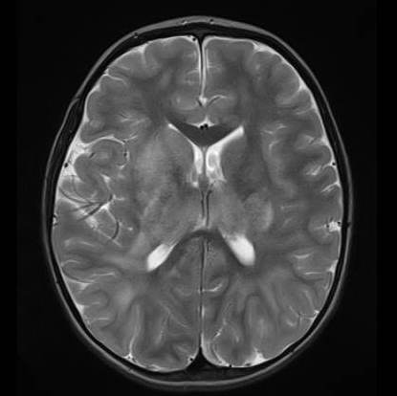
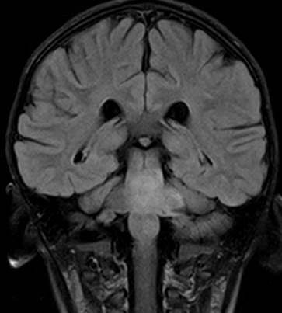
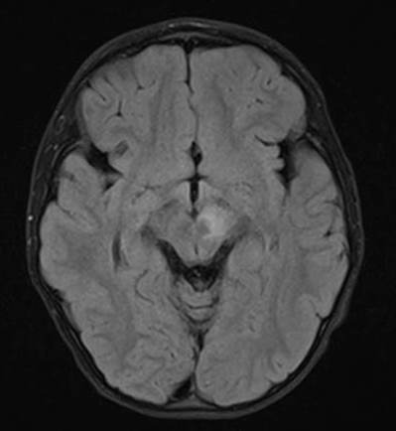
A
B
C

Other rare clinical phenotypes associated with MOG-Abs positivity include brainstem presentations,
which is usually associated with fluffy brainstem lesions typically located in the pons, medulla, or cerebellar peduncles,⁷³ and cortical encephalitis, characterized by unilateral cortical lesions presenting with epileptic seizures, sometimes in association with abnormal behaviour or focal symptoms.^{72,96,97} In addition, reduction/resolution of brain and spinal cord lesions on follow-up is typical for MOG-Abs related disorders.⁹⁸

Figure 20. Radiological profile of a 31-year-old MOG-Abs positive case with a clinical profile suggestive for encephalitis observed in our unit.⁹⁵ Cortical and subcortical damage (A-B) with severe bilateral involvement of thalamus and internal capsule (B), mesial temporal lobes (C) and pons (D) in absence of contrast enhancement, is seen on brain MRI performed ad onset. After treatment with intravenous immunoglobulins a significant improvement was noted with an almost complete resolution of the cortical, thalamic and basal ganglia involvement (E-F) and a reduction of temporal (G) and brainstem lesions (H).
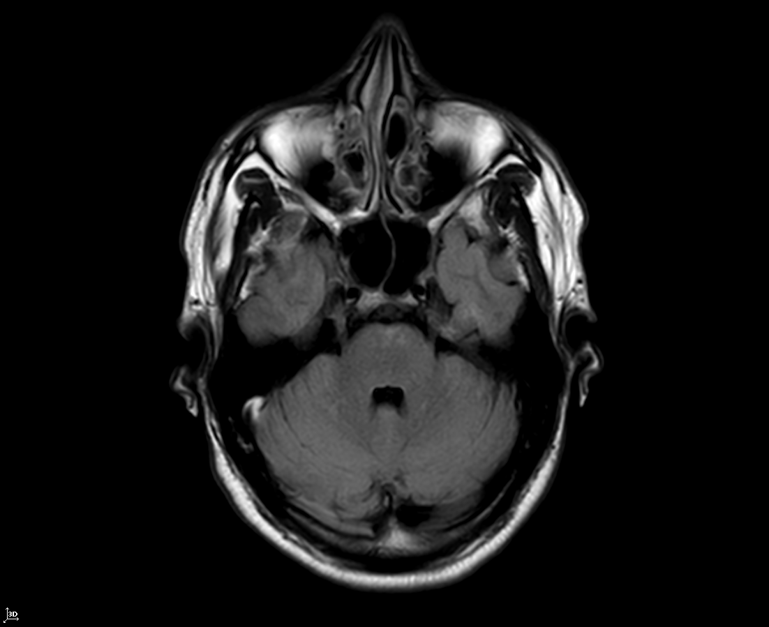
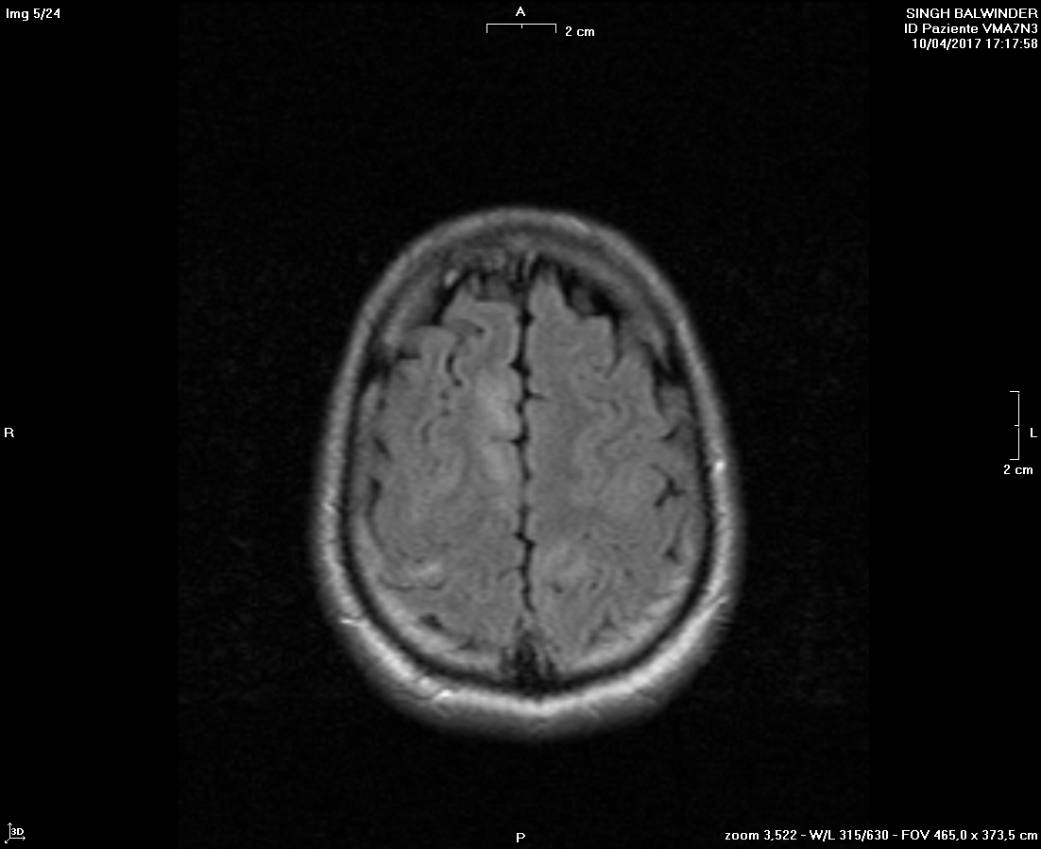
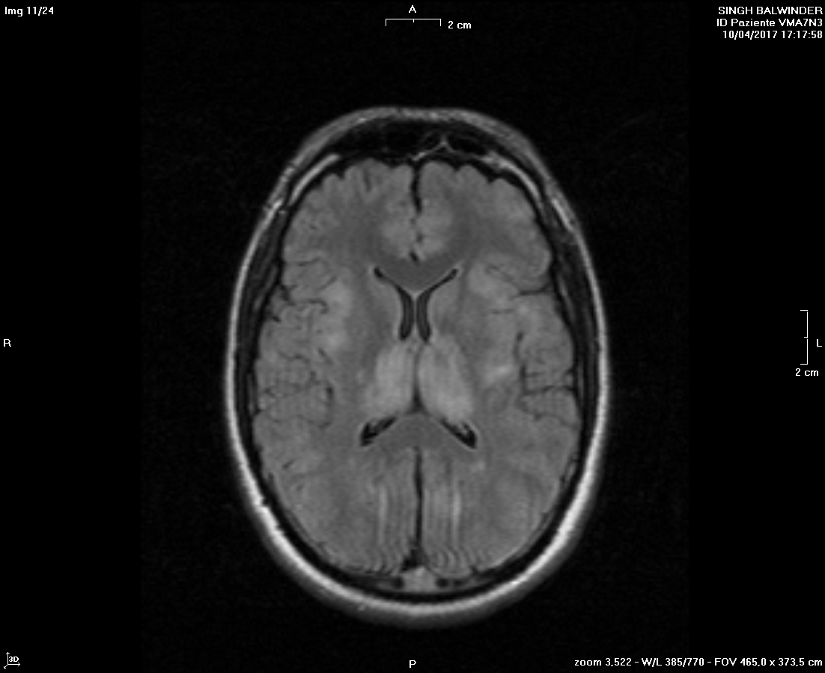
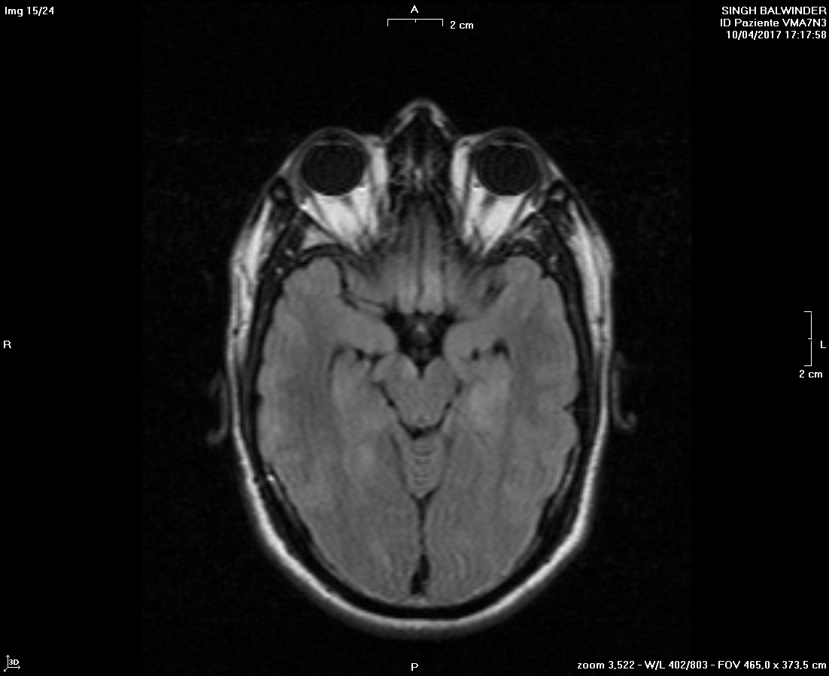
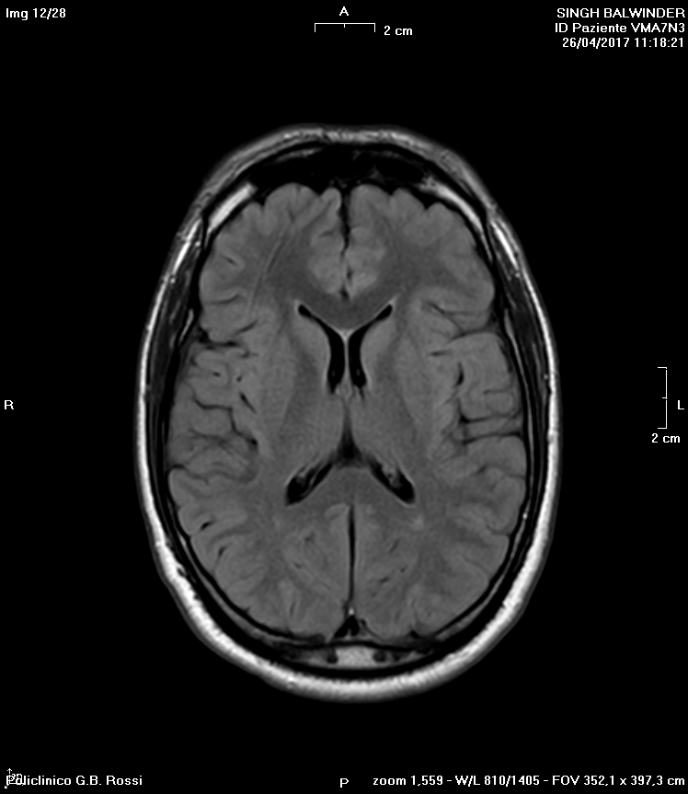
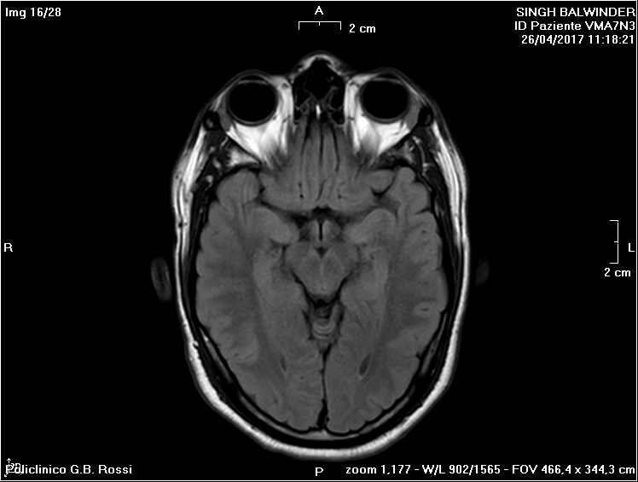
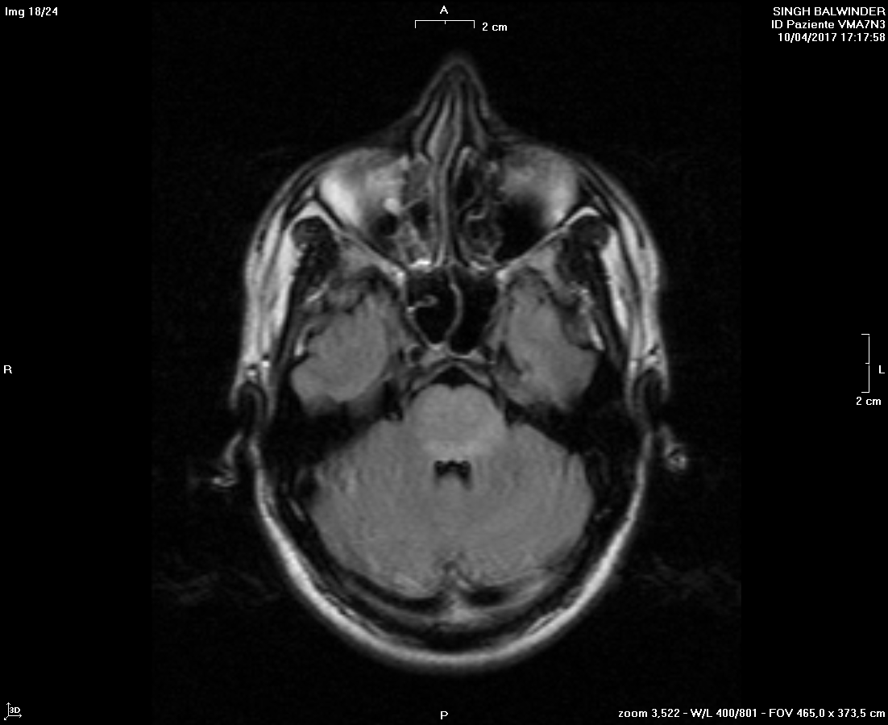
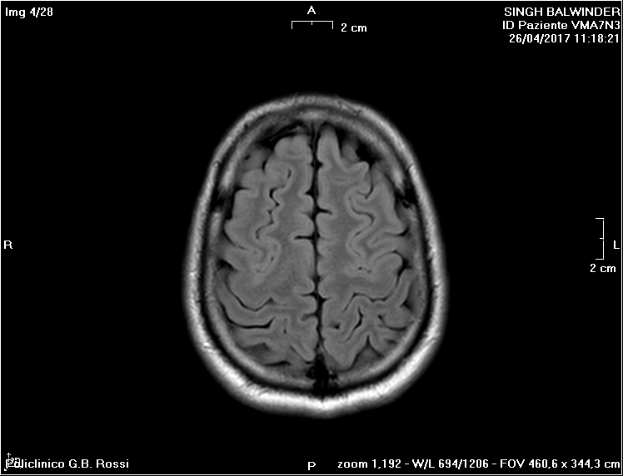
A
B
C
D
F
G
H
E

Supporting features of MOG-Abs related conditions include also absence of CSF restricted oligoclonal bands (67-90%) and increased of white cell counts (33-70%) Jarius part II and Mariotto J Neurol 2017; Cobo-Calvo 2018.

Disease course can be either monophasic or relapsing (30%-70% of cases), with relapses occurring most frequently in the first year after onset and influenced by acute treatment choices.^{73,86,99} Relapses are considered less common in this condition than in AQP4-Abs positive NMOSD, manifest more common with ON, and have a great impact on disability.¹⁰⁰ In addition, patients with ON at onset seem to relapse more frequently than those with myelitis or ADEM.⁷³ Up to now, only monitoring of MOG-Abs titer has been proposed as a possible predictor of disease course. In particular, disappearance of MOG-Abs in serum is considered prognostic of cessation of relapses,^{72,99,101} although seropositivity can be maintained over years even without clinical activity.¹⁰² On the other hand, MOG-Abs titer at onset does not predict the future disease course in term of risk of relapses or final outcome.¹⁰³
As a consequence, antibody titers can help treatment decisions but seem not reliable enough to be used in the clinical setting for patients’ management.¹⁰⁴
MOG-Abs related disorders have usually a favourable prognosis, with a full/good recovery observed in 78% of cases. However, patients can be left with significant sphincter/erectile dysfunction, cognitive impairment, and poor visual acuity, mainly driven by onset attack. Good recovery is more frequent in cases with unilateral ON or ADEM and in younger patients.⁷³
According to these data, MOG-Abs positivity seems to delineate an autonomous entity, which can’t be incorporated in other well-known phenotypes. As a consequence, different authors proposed possible diagnostic criteria for MOG-Abs associated disorders.^{101,105}

Figure 21. Criteria for MOG related encephalomyelitis proposed by Jarius and colleagues (all of the following criteria have to be satisfied). “Possible MOG related encephalomyelitis” can be diagnosed in presence of red flags (i.e. progressive disease course or atypical clinical/radiological findings) and when presence of MOG-Abs has not been confirmed using methodologically different CBA.¹⁰⁵



Figure 22. Criteria proposed by Lopez-Chiriboga and colleagues to perform a diagnosis of MOG-Abs associated disorders.¹⁰¹

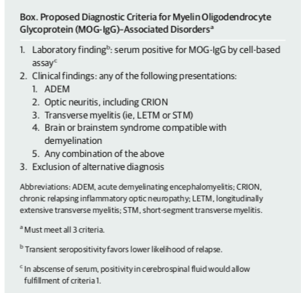

1.2.3 Treatment strategies
To date, there are no standardized guidelines for the treatment of MOG-Abs associated disorders, so that heterogeneous treatment choices based on personal decision are often used, in particular on maintenance therapy. Similar to other inflammatory demyelinating conditions, intravenous steroids, in association with PE or IVIG in severe cases, are administered in the acute stage and have a demonstrated favourable impact on clinical outcome.^{74,100,106,107} Prolonged oral steroids seem to reduce relapse risk and are recommended for 6-12 months after the acute event, depending on persistence of MOG-Abs positivity.⁷³ However, the heterogenous clinical course and disability outcomes raise doubts on the use of maintenance therapy after the first episode. Attack severity does not predict relapse rate, and treatment decisions are usually based on persistence of MOG-Abs antibodies and residual disability. In relapsing cases, treatment decisions are easier and immunosuppressants, in particular azathioprine (AZT), mycophenolate mophetil (MMF), and rituximab (RTX) are demonstrated to reduce relapse risk with a subsequent effect on disability.^{100,107,107,108} Treatment with Tocilizumab has been described as effective in single unresponsive and active cases.^{109,110} On the other hand, MS disease-modifying drugs are ineffective in MOG-Abs positive patients, highlighting the importance of an appropriate identification and differential diagnosis between these conditions. Repeated IVIG have been demonstrated to prevent relapses in children, particularly in those with multiple relapses a year.¹⁰⁸ All together, these observations underline the importance of a correct identification of MOG-Abs positive cases so that adequate treatments can be administered.^{73,78}

1.2.4 Neuropathological aspects
Few pathological reports of MOG-Abs positive cases have been described, showing loss of MOG immunoreactivity, astrocytes preservation, reactive gliosis, preservation of axons, and active demyelinating lesions in accordance with pattern II demyelination. Inflammatory infiltrates composed of macrophages, CD3/CD8-positive T cells, and perivascular B cells with deposits of activated complement have been also described.^{111,112,113,114}

1.2.5 Pathogenesis
The pathogenicity of autoimmune response to MOG has been well established and supported by different studies in animal models showing its encephalitogenic properties with a T-cell and complement-fixing Abs mediated pathology.¹¹⁵ Notably, pathogenic MOG-Abs that recognize conformational epitopes have effect only after reaching the CNS through an opening of the blood-brain barrier. In vitro, MOG-Abs can activate complement and cellular-dependent cytotoxicity.¹¹⁶⁻¹¹⁸ On the other hand, human MOG-Abs pathogenicity in vivo in rodent models remains to be completely clarified. In particular, mice intracerebral injection of human MOG-Abs causes no complement-mediated demyelination with only subtle effect on oligodendrocytes. In addition, peripheral injection of human MOG-abs into rats with EAE does not cause demyelination.^{116,119} Possible explanations of these findings can be the absence of reactivity of human MOG-Abs with rodent MOG or the fact that titers and affinities are not sufficiently high. Recently, inflammation and complement-mediated demyelination have been observed in rats with T cell-mediated EAE after intracerebral injection of MOG-Abs reacting with rodent MOG,¹²⁰ providing evidence that, when interacting with T cells, MOG can be pathogenic in vivo.⁵⁷

  - Neurofilament light chain (NfL)
1.3.1 General considerations and diagnostic techniques
Neurofilament are cylindric proteins located in dendrites, soma, and in particular axons of neurons, with the specific role of confer structural stability and promote axonal growth and intracellular transport. They are classified as intermediate filaments (i.e. 10 nm of diameter, which is intermediate between actin and myosin) and include neurofilament light chain (NfL), neurofilament middle chain (NfM), neurofilament heavy chain (NfH), and -internexin, depending on the length of the carboxy-terminal region. Since NfL represent the most abundant and soluble subunit, research mainly focused on them.¹²¹

Figure 23. Structure of neurofilament.¹²¹

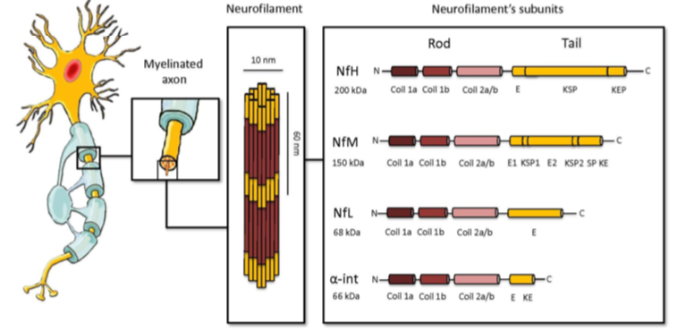

Low levels of NfL are constantly released from axons under normal conditions, in an age-dependent manner. However, as a consequence to axonal damage due to inflammatory, degenerative, vascular, or traumatic injury, NfL release significantly increases. After reaching the interstitial fluid, NfL are detectable in the CSF and, at lower but comparable levels, in serum.¹²² ELISA technology allows the measurement of NfL in the CSF; however, the significantly lower levels detectable in serum requires the use of ultrasensitive assay. This single-molecule array allows simultaneous counting of singulated capture microscopic beads that carry sandwich antibody complexes and enables reliable measurement of the low NfL concentrations detectable in serum and monitoring minor changes over time.¹²³ With this recent developed technique, a significant increase of serum NfL levels has been demonstrated in different conditions, including Alzheimer’s disease,¹²⁴ Creutzfeldt-Jakob disease,¹²⁵ frontotemporal dementia,¹²⁶ amyotrophic lateral sclerosis,¹²⁷ parkinsonian disorders,¹²⁸ traumatic brain injury,¹²⁹ stroke,¹³⁰ peripheral neuropathies,¹³¹ autoimmune encephalitis,¹³² and in particular MS,¹³³ in correlation with disease activity and post-mortem neurodegeneration.¹³⁴ The lower invasiveness of serum NfL measurement allows repeatable analyses over time and promotes the role of NfL as a biomarker of disease activity and treatment response in a wide spectrum of neurological disorders.

1.3.2 NfL in patients with MS
CSF and serum NfL concentration has been demonstrated to be increased in patients with MS and clinically isolated syndrome (CIS), in correlation with clinical and radiological activity.^{122,135,136} Higher NfL levels are detected in patients with a recent (i.e. occurred within 2-3 months) relapse¹²¹ and in patients with CIS who will convert to MS.¹³⁷ CSF levels of NfL measured at the time of diagnosis seem to be an early predictive marker of long-term outcome and conversion to a progressive disease course,¹³⁸ and to be an indicator of cognitive impairment in MS patients.¹²¹ In addition, CSF NfL levels are predictor of CIS and MS in patients with radiologically isolated syndrome and have been proposed to select patients who may benefit from early treatment to delay conversion outcomes.^{139,140} After the demonstration of a strong correlation between serum and CSF NfL values in MS patients,¹⁴¹ serum was used as a more accessible and noninvasive specimen to monitor disease activity. Serum NfL levels have been demonstrated to correlate with lesion load detected on brain MRI and predict onset of new radiological lesions, brain atrophy, relapse rate, and disability worsening over disease course.^{122,133,142-146} Recently, serum NfL values have been measured in a cohort of MS patients with 12 years’ follow-up. Baseline values correlated with disease subtype, relapses, treatment status and EDSS at sampling. However, a significant association with relapse activity over time and future EDSS worsening was not detected.¹⁴⁷ Finally, NfL levels have been proposed as a promising monitoring biomarker for personalized therapeutics in MS patients, as they decrease during treatment in correlation with disease activity.^{142,148-150} Altogether, the large majority of published data support the role of NfL as possible predictors of disease outcome and response to disease-modifying treatments in patients with MS.

1.3.3 NfL in NMOSD and related conditions
Previous reports described astrocytic damage as a primary pathologic process in NMOSD, rising doubts on the utility of measure NfL levels in this condition. In particular, glial fibrillary acid protein (GFAP) had been indicated as a biomarker of astrocytic damage and clinical severity in patients with NMOSD.¹⁵¹ Moreover, it was shown that myelin basic protein is elevated in the CSF of both AQP4-Abs and MOG-Abs positive patients as compared with MS patients, while GFAP is higher only in AQP4-Ab- positive ones, reflecting either myelin injury or astrocyte damage, respectively.¹⁵² In this scenario, the role of axonal damage reflected by elevation of neuron-specific biomarkers located in axons was unclear. An increase of NF-heavy and light chains has been demonstrated in CSF of patients with NMOSD compared with MS cases, suggesting the implication of axonal injury.¹⁵² However, previous reports were mainly focused on CSF analysis, and did not account for the presence of specific antibodies which might induce prominent damage at their target site. We recently analysed serum NfL in patients with NMOSD and related disorders and, when comparing cases with AQP4-Abs, MOG-Abs and seronegative patients, we observed increased serum NfL levels in patients with AQP4-Abs and MOG-Abs. In particular, we detected higher NfL levels in AQP4-Abs positive subjects, and this might in part explain the more severe clinical phenotype observed in these patients, reflecting the axonal injury induced by astrocytic and complement-mediated cellular damage. On the other hand, we also detected relatively increased levels of NfL in MOG-Abs positive patients, reflecting the long-term disability described in many MOG-Abs positive cases and suggesting that myelin and neuronal damage may coexist in this condition.¹⁵³

Table 2. Serum NfL levels in patients with NMOSD and related disorders, MS, and healthy controls according to antibody reactivity against AQP4-Abs and MOG-Abs.¹⁵³
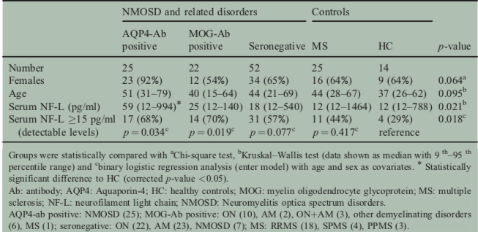
We then replicated these observations focusing on 38 MOG-Abs positive patients and assessing serum and CSF NfL concentration according to clinical/paraclinical characteristics to investigate NfL as biomarkers of disease severity in this condition. We observed that: (1) NfL levels are increased in older patients, likely reflecting age-dependent neuronal degeneration; (2) serum NfL levels are significantly increased in MOG-Abs positive cases compared with controls, suggesting that significant axonal damage could occur in this condition; (3) serum and CSF NfL values are significantly correlated in MOG-Abs-associated disorders, providing evidence that blood sampling can be reliably used to measure NfL concentration in this condition; (4) serum NfL correlates with attack severity and might predict long-term outcome in MOG-Abs-related disorders. These observations support the broader use of NfL as an accessible and repeatable biomarker of tissue damage in MOG-Abs-related conditions, where it is essential to improve the prediction of short and long-term prognosis.¹⁵⁴ More recently, the analysis of NfL in a group of 33 NMOSD patients (30 seropositive for AQP4-Abs) reported increased levels in comparison with those detected in healthy controls together with a significant correlation between serum and CSF values and a significant association between NfL levels and age. In addition, serum NfL were increased during relapses and correlated with EDSS score but were not influenced by treatment and did not predict next year relapse.¹⁵⁵

2. Objectives of the study
- To assess serum NfL concentration in a wide cohort of patients with MOG-Abs related conditions according to clinical/paraclinical characteristics
- To evaluate intraindividual changes over time
- To validate the use of NfL as a biomarker to predict disease course and guide therapeutic interventions in clinical practice

3 Materials and Methods
For this study we obtained the approval of the local ethics committee (study number 1052CESC). All patients consented to diagnostic procedures and biological sample storage at Verona Neuropathology Laboratory.
3.1 Study subjects
We identified patients referred by the treating physicians for MOG-Abs assay to the Laboratory of Neuropathology, University Hospital of Verona, Italy, between February, 2015 and August, 2019. Of the 1330 consecutive samples that were analysed, 66 resulted MOG-Abs seropositive in either serum, CSF, or both. Among these, we included in this study 63 patients with available clinical and paraclinical data. An additional group of 40 anonymised serum samples from age-matched unaffected controls was also analysed for comparison.
3.2 Clinical/radiological data and diagnosis
For all 63 included subjects, demographic, clinical data at sampling and at last follow-up, and MRI findings were analysed and collected from medical records and reports obtained from referring physicians in standardised case report forms. The attack at sampling (index attack) was considered “severe” when severe motor impairment (ambulation index > 3) and/or encephalopathy and/or severe visual impairment (worse eye visual acuity <2/10) occurred, or when the Expanded Disability Status Scale (EDSS) score was > 4. Otherwise the attack was considered mild to moderate. The clinical course was classified as monophasic when only one clinical acute/subacute event occurred or relapsing in patients with one or more relapses defined according to McDonald criteria.³ Clinical activity was defined by relapse occurrence with or without worsening of disability reported by referring neurologist. Radiological activity was supported by the presence of gadolinium-enhancing lesions or new or unequivocally enlarging T2 lesions on brain/spinal cord MRI in comparison with a previous scan.⁴
MRIs were obtained with different ≥ 1.5 Tesla scanners and included at least axial and sagittal (or volumetric) T2 and fluid attenuated inversion recovery (FLAIR) sequences with slice thickness ≤ 3 mm, and post contrast sequences were evaluated. The presence of any abnormal finding, the number of focal lesions, gadolinium-enhancing lesions, and the involvement of the optic nerve were reported. Spinal cord lesions were classified according also to longitudinal extension ≥3 vertebral segments or less. In case of available samples during the follow-up, the clinical and radiological status at each time of follow-up sampling was determined. At last follow-up visit, at least 1 month after the index event, recovery was considered complete if neurological examination was normal and no symptoms were reported (expanded disability status scale—EDSS—score 0 or equal to baseline value), absent if no improvement was observed (EDSS score at last follow- up ≥ EDSS score at nadir), partial in all the other cases. According to data available at last follow-up, clinical diagnosis was defined according to 7 diagnostic categories: (1) MS;⁵ (2) NMOSD;²⁰ (3) chronic relapsing inflammatory optic neuropathy (CRION);⁵² (4) ADEM;⁹ (5) ON; (6) idiopathic acute transverse myelitis (IATM);⁴⁷ (7) other demyelinating disorders. Idiopathic ON and/or TM were defined as one or more episodes of acute/subacute optic neuropathy and/or myelopathy of inflammatory origin (based on clinical, radiological and/or CSF evidence) not fulfilling diagnostic criteria for MS, NMOSD, and ADEM and not attributable to other causes. Other demyelinating disorders were characterised by inflammatory conditions defined by clinical, CSF and radiological evidence, with multifocal lesions not included in the disorders previously mentioned. Based on the revision of all available data at the time of last follow-up visit, two investigators (AG, SM) blinded to MOG-Abs assay result classified each patient according to the diagnostic criteria mentioned above.
3.3 AQP4-Abs and MOG-Abs analysis
Blood samples were collected using plastic tubes without anti-coagulant (vacuum tube GEL & CLOT ACT, 5 mL REF 10020, Vacutest Kima, Arzergrande, Padova, Italy), centrifuged, and stored at −80 °C. In all cases, the presence of serum AQP4-Ab was analysed using a commercially available cell-based assay (Anti-Aquaporin-4 IIFT, Euroimmun, Lübeck, Germany), according to manufacturer instructions. In negative cases with a history strongly suggestive of NMOSD, an additional analysis was performed at the Neuroimmunology Laboratory of Innsbruck, using an in- house AQP4-transfected live cell assay.¹¹⁷ The presence of MOG-Abs was analysed by two independent investigators at the Verona Neuropathology Laboratory using recombinant live cell-based immunofluorescence assay with HEK293A cells transfected with full-length MOG (human MOG alpha-1 EGFP fusion protein), as previously described.¹¹⁷ Briefly, we performed the live cell staining immunofluorescence test 24 h after transfection. After a 10 min blocking step with goat IgG (Sigma-Aldrich) in PBS/10% FCS (both Sigma-Aldrich), cells were incubated with the serum samples diluted 1:20 and 1:40 in PBS/10% FCS for 1 h at 4 °C. After three washing steps with PBS, 10% FCS cells were incubated with CyTm 3-conjugated goat anti human IgG antibody (H+L, Jackson ImmunoRe- search Laboratory, West Grove, PA, USA; diluted 1:200 in PBS/10% FCS) for 30 min at room temperature. Cells were washed twice and stained with DAPI (Sigma-Aldrich, diluted 1:10,000 in BS/10% FCS) to exclude dead cells, and immediately analysed with a fluorescence micro- scope (Zeiss, Axio Vert.A1). Only serial study numbers were provided and the clinical and radiological data were unknown to all the testing subjects. Sera were tested at dilutions of 1:20 and 1:40, and MOG-Abs positivity was titrated with serial dilutions with a threshold of 1:160 to define MOG-Abs positivity as previously established.⁸⁶ In patients positive for MOG-Abs who had available serum samples during the follow-up, repeated analysis of MOG-Abs was performed. MOG-Abs were also analysed in CSF when paired CSF samples were available or in seronegative cases highly suggestive for MOG-Abs-related conditions. CSF samples were tested undiluted and at 1:2 dilution, with subsequent serial titrations. When MOG-Abs were detected in CSF only, further analyses using anti-human IgG-Fc and anti-human IgM-µ (Jackson ImmunoResearch Laboratory, West Grove, PA, USA; diluted 1:750) secondary antibodies were performed at the Neuroimmunology Laboratory of Innsbruck, to confirm the selective presence of MOG-IgG.
3.4 NfL analysis
Measurement of NfL concentration was performed in duplicates in all available sera and paired CSF (i.e. obtained within one month) of included cases and in sera of healthy controls. A control of NfL value was performed in available follow-up serum samples. Investigators blinded to clinical data analysed NfL concentration using SIMOA Nf-light ® kit in SR-X immunoassay analyzer, SimoaTM (Quanterix Corp, Boston, MA), which runs ultrasensitive paramagnetic bead-based enzyme-linked immunosorbent assays. Briefly, frozen samples and calibrator were equilibrated to room temperature and diluted with specific sample diluent. Calibrators, samples, detector, and beads were dispensed in each well and plates were incubated at 30°C with shaking 800 rpm for 30 minutes. After washing steps, 100 μl SBG was added to each well and plates were incubated at 30°C with shaking 800 rpm for 10 minutes. After washing steps, beads were resuspended twice at 1000 rpm for 1 minute. A final washing step was performed and plates were dried for 10 minutes before being transferred to the SR-X for reading.
3.5 Statistical analysis
Continuous and categorical variables were reported as median (range) and percentages, respectively. Mann-Whitney U test was used for pairwise comparison of NfL levels within and between groups. Correlations were analysed computing the Spearman correlation coefficient. Statistical significance was set at alfa<0.05 two-tailed. Analyses were performed using SPSS Statistics version 21 (IBM Corp., USA).

4. Results

4.1 Demographic, clinical, and paraclinical data of MOG-Abs positive cases.
Demographic, clinical and MRI data of MOG-Abs positive patients included in the present study are summarised in Table 3.

Table 3. Clinical and paraclinical characteristics observed in the analysed cohort.

Number of cases analysed | 63
Age at sampling, median (range), years | 39 (6-75)
Female, n (%) | 34 (54%)
Symptoms at sampling, n (%)  ON  Myelitis  ON+myelitis  Encephalopathy  Encephalomyelitis  None  Area postrema syndrome | 26 (41.3%)  19 (30.1%)  2 (3.2%)  7 (11.1 %)  2 (3.2%)  6 (9.5%)  1 (1.6%)
Attack at sampling  Severe, n (%)  EDSS, median (range) | 20 (31.7%)  2.0 (0-8.5)
Optic neuritis (ever), n (%) | 39 (61.9%)
Myelitis (ever), n (%) | 35 (55.5%)
Course, n (%)  Monophasic  Relapsing/evolving | 32 (50.8%)  31 (49.2%)
Activity at sample, n (%)  Clinical activity  Radiological activity | 49 (77.8%)  41 (65.1%)
Disease duration from onset to sampling,  median (range), months | 2 (0-264)
Final Diagnosis, n (%)  ON/CRION  Myelitis  NMOSD  MS  ADEM  Other demyelinating disorders | 20 (31.8%)  7 (11.1%)  5 (7.9%)  5 (7.9%)  5 (7.9%)  21 (33.4%)
Follow-up, median (range), months | 21 (1-266)
Final outcome, n (%)  No improvement  Partial recovery  Complete recovery | 6 (9.5%)  34 (54.0%)  23 (36.5%)
EDSS at last evaluation, median (range) | 1 (0-7.0)
BRAIN MRI at sampling
T2 inflammatory lesions, n (%)  None  One-Two  More than two | 29 (46.0%)  11 (17.4%)  23 (36.6%)
Optic nerve involvement, n (%)  None  Unilateral  Bilateral | 46 (73.0%)  9 (14.3%)  8 (12.7%)
Enhancing lesions, n (%) | 10 (15.9%)
SPINAL CORD MRI at sampling
Number of cases analyzed | 57
T2 inflammatory lesions, n (%)  None  One-Two  More than two | 33 (57.9%)  11 (19.3%)  13 (22.8%)
LETM at sampling, n (%) | 5 (8.8%)
Enhancing lesions n, (%) | 11 (19.3%)
LABORATORY DATA
MOG-Abs titer, median (range) | 1:320 (0-1:81920)
NfL serum pg/ml, median (range) | 10.6 (1.7-101.5)
NfL CSF pg/ml (n=17), median (range) | 455.1 (165.7-3919.8)

In particular, the cohort was composed mainly of adults; only 3 MOG-Abs positive cases were considered paediatric at sampling. Gender was almost equally distributed in the analysed cohort (figure 24).
Figure 24. Gender distribution in the analysed cohort.

Symptoms observed at first sampling were consistent with the classical phenotype of MOG-Abs related conditions, with optic neuritis and myelitis depicted as the prevalent manifestations (figure 25). In addition, manifestations related to optic neuritis and myelitis were frequently observed during the whole course of the disease (61.9% and 55.5% of cases, respectively).

Figure 25. Symptoms observed at first sampling in the included cases.

The attack was usually considered non-sever (68.3%) with a median EDSS at first sampling of 2.0 (range 0-8.5) and most patients were clinically (77.8%) and radiologically (65.1%) active at first sampling.

No significant difference was observed in the disease course (figure 26).

Figure 26. Course observed during the follow-up in the analysed patients.

A wide range of final diagnoses were depicted at last available follow-up, with the most frequent characterized by ON/CRION and “other demyelinating disorders”, which could not be classified according to well-established diagnostic criteria (figure 27).

Figure 27. Final diagnosis in the analysed patients.

In addition, at last available follow-up (median 21 months, range 1-266), the majority of patients had only a partial recovery, with a median EDSS of 1, range 0-7 (figure 28).
Figure 28. Outcome observed at last follow-up in the included patients.

On brain MRI, T2 inflammatory lesions were often not detectable (figure 29), in absence of optic nerve involvement, also in patients with symptomatic ON (figure 30).

Figure 29. Number of brain T2 inflammatory lesions observed at first sampling in included cases.

Figure 30. Type of optic nerve involvement in the analysed cohort.

Of note, spinal cord lesions were usually absent at first sampling and, when detectable, characterized by short myelitis (figure 31 and 32).

Figure 31. Distribution of spinal cord lesions in included subjects.

Figure 32. Presence of short and longitudinally extensive myelitis in the analysed cohort.

Median serum MOG-Abs titer was 1:320 (range 0-1:81920), with negative (< 1:160) serum MOG-Abs observed in the 3 cases with isolated CSF MOG-Abs. Serum NfL values measured at first sampling were significant higher in patients (median 10.6 pg/ml, range 1.7-101.5) than in healthy controls (median 6.0 pg/ml, range 1.3-13.8, p=0.01) and significantly higher in CSF (median 455.1 pg/mL, range 165.7-3919.8) than in serum. The isolated CSF MOG-Abs positive cases had serum NfL levels in line with MOG-Abs seropositive ones, but had higher CSF NfL levels (median 2713.5, range 1975.7-3919.8) in comparison with seropositive ones (median 440.5, range 165.7-2281.8).
However, the clinical/radiological phenotype of these patients were in line with those observed in seropositive ones.
Among seropositive cases, no difference was noted in CSF NfL values between those who had MOG-Abs in both serum and CSF (N=6; median 466.5, range 165.7-2281.0) and those who were exclusively seropositive (N=8, median 440.5, range 191.4-715.7). Further details are reported in Table 3.

4.2 Correlation between clinical and paraclinical characteristics of MOG-Abs positive cases and NfL values.

As expected, we observed a moderate correlation between serum NfL values and age at sampling, with higher levels detected in older patients (r_{s}=0.41, p=0.001).

Figure 33. Correlation between serum NfL levels (X) and age (Y) at first sampling in the analysed cohort.

On the other hand, no significant difference was noted on NfL values distribution according to gender (data not showed).
In patients with serum and CSF samples available (n=17), a moderate correlation was observed between paired values (r_{s}=0.423, p=0.09).

Figure 34. Correlation between serum (X) and CSF (Y) NfL values.

In addition, no correlation was noted between serum MOG-Abs titer and serum NfL levels (r_{s}=0.146, p=0.114).

Figure 35. Correlation between serum NfL values (X) and MOG-Abs titer (Y).

Interestingly, NfL values correlated significatively with disability at sampling (r_{s}=0.43, p<0.001) but, when measured at onset (i.e. within 2 months from onset, n=32) did not correlated with final disability (r_{s}=0.061, p=0.738).

Figure 36. Correlation between serum NfL values (X) and EDSS at sampling (Y).

Figure 37. Correlation between serum NfL values measured at onset (X) and EDSS at last follow-up (Y).

Although radiologically active patients tend to have higher values of NfL in comparison with inactive ones (median 11.0 pg/mL, range 3-101.5 vs median 8.4 pg/mL, range 1.8-59), the difference between the two groups was not significant, also after adjusting for age or when considering the different clinical phenotypes separately (i.e. optic neuritis vs myelitis).
Similarly, clinically active subjects tend to have higher NfL levels (median 10.8 pg/mL, range 1.8-101.5) in comparison to inactive ones (median 8.3 pg/mL, range 2.1-37.3), but the difference was not significant. Finally, NfL values did not differentiate monophasic and relapsing cases.

4.3 Significance of monitoring NfL values over time in MOG-Abs positive patients.
Sixty follow-up samples of 28 patients were available for NfL measurement in course of follow-up. Most of these measurements (n=55) were performed in absence of clinical and radiological activity. NfL levels decreased (n=30) or remain stable (n=23) in comparison with first measurement in most cases over time, in parallel with a decrease of clinical disability. NfL levels decreased also in the 3 patients in whom samples were obtained on relapse, always in parallel with a decrease of the EDSS score in compare with first event. In particular, this observation was confirmed in a representative case by repeated serum NfL measurement over time. This patient presented with bilateral ON at onset and had 3 relapses occurring as symptomatic optic neuritis confirmed by radiological optic nerve involvement (figure 39).
Figure 38. NfL monitoring over time in comparison with EDSS in a patient with a monophasic disease course and a complete recovery at last follow-up.

Figure 39. NfL monitoring over time in comparison with EDSS in a patient with a relapsing disease course and a complete recovery at last follow-up. Relapses are marked by arrows. As showed, NfL levels do not increase significatively in course of relapses.

5. Discussion
We here report NfL analysis at first sampling and during the follow-up in a group of patients with MOG-Abs associated disorders, extending our previous study performed in a smaller cohort.¹⁵⁴ In the present study, MOG-Abs-positive cases had overall clinical features in line with previous reports, with an almost equal distribution among genders and a low predominance of females in comparison with AQP4-Abs positive subjects.^{72,73} We also confirm that optic nerve and spinal cord are the preferential anatomical sites clinically involved at the onset and during the follow-up.^{74,81,86} Of note, simultaneous optic nerve and spinal cord involvement was rare in our cohort, as well as clinical/radiological signs of area postrema syndrome, again in contrast to AQP4-Abs-related disorders. Our data also provide evidence that MOG-Abs-associated conditions are generally less severe that AQP4-Abs-related ones, in term of attack severity, course, and final outcome. A similar finding was recently reported in a cohort of MOG-Abs positive pediatric cases, where a favorable outcome and a monophasic course was observed in the majority of patients.¹⁵⁶ However, the moderate relapse risk and permanent -despite generally low- disability observed in the majority of our cases confirms previous data⁷³ and support the administration of appropriate treatment strategies in this condition. We also confirm our previous observation of the evidence of an inflammatory disorder not fulfilling diagnostic criteria for MS, NMOSD, or ADEM at last follow-up in the majority of patients. The diagnosis of ADEM was infrequent in our group of patients, consistently with the rarity of ADEM cases in adults. We have also to mention that some MOG-Abs positive cases retain a diagnosis of MS, in line with previous reported evidence.¹⁵⁷ In addition, normal spinal/brain MRI findings were detected in a consistent group of patients.⁸⁶ A higher frequency of short myelitis than those reported in AQP4-Ab-associated disorders was also observed.⁸⁸ Taken together, these aspects support the concept that MOG-Abs delineates a separate heterogeneous condition, which needs specific diagnostic criteria, as recently proposed by different groups.^{101,105}
Notably, we also confirm our previous evidence of exclusive CSF MOG-Abs in some patients with a consistent phenotype, supporting the analysis of both serum and CSF samples in seronegative cases with a highly suggestive phenotype.⁷¹ Interestingly, CSF only MOG-Abs positive cases had higher CSF NfL values in comparison with seropositive ones, suggesting that axonal damage might be more prominent in patients with isolated CSF MOG-Abs although this finding was not paralleled by clinical and MRI data. On the other hand, the absence of prognostic factors in MOG-Abs-related diseases supports the study of NfL as biomarkers of disease activity in this condition. Repeated measure of MOG-Abs titer over time has been proposed to monitor disease activity. Longitudinally persistent positivity has been associated with higher risk of relapses.⁹⁹ However, relapses can occur in seronegative cases and persistently seropositive patients might have a monophasic course.¹⁵⁶ Taken together, these observations confirm the lack of useful measure of disease activity in MOG-Abs positive patients, making NfL values an attractive biomarker for monitoring this condition. We here confirm in a larger cohort our previous observation of increased NfL values in patients with MOG-Abs, supporting the presence of axonal damage in this disorder. This concept retains both clinical and pathological implications and suggests the presence of a concomitant axonal involvement in a condition where oligodendrocytes are the main target. Despite the absence of evident axonal damage in the few neuropathological analyses of MOG-Abs positive cases reported,¹⁵⁸ demyelination together with inflammatory infiltrates and complement activation have been described.¹¹⁴ These similarity with the neuropathological aspects of “patter II MS” might be the basis of the significant axonal damage detectable in both conditions.
We herein confirm that serum and CSF NfL levels are correlated, reinforcing the utility of serum analysis as a more accessible and repeatable measure of disease activity and expanding the possible use of NfL as a valuable biomarker. Interestingly, we found a significant correlation between NfL values and EDSS, supporting the utility of measuring NfL levels as an additional marker of disability. These observations could provide novel support in delineating treatment strategies in the acute stage of this condition, where disease course and treatment response can be difficult to be correctly determined using scales specifically designed for other inflammatory conditions. In this scenario, higher NfL levels could share same aspects with MOG-Abs titer, and, in particular, the association with a more severe presentation and the inability to predict final outcome.¹⁰³ However, although not constantly, higher MOG-Abs titers are usually observed during relapses, with a decrease of MOG-Abs titer in monophasic cases. On the contrary, we herein observed a decrease/stabilization of NfL values over time in most patients, which was independent from clinical and radiological activity. This observation is discordant from data reported in MS patients, where NfL levels correlate with clinical and radiological activity^{122,145,136} and increase in course of relapse.¹²¹ This discrepancy is also supported by the lack of association between NfL values, risk of relapse, and radiological measure of disease activity and, as previously suggested, might indicate that NfL levels mainly reflect the extent of axonal damage occurring at disease presentation rather than overall disease activity. These findings could also provide novel cues into MOG-Abs pathogenesis, suggesting that axonal damage could occur early during disease course and tends so stabilize over time.
Our study is limited by several factors including the retrospective design and the wide heterogeneity of intervals between repeated sampling over time. Future prospective studies which take into account these aspects will be informative.

6. Conclusion
This study provides novel data supporting the role of serum NfL as easily accessible biomarkers of neurological disability in MOG-Abs related disorders. Future prospective studies with regular monitoring of NfL over time and a prolonged follow-up will help to delineate the utility of NfL in the clinical setting.

7. References

- Thompson A. Multiple sclerosis: the upward trajectory continues. Lancet
Neurol. 16(1):10-12; 2017.
- Brownlee WJ, Hardy TA, Fazekas F, Miller DH. Diagnosis of multiple sclerosis:
progress and challenges. Lancet. 389(10076):1336-1346; 2017.
- Polman CH, Reingold SC, Banwell B, Clanet M, Cohen JA, Filippi M, Fujihara K,
Havrdova E, Hutchinson M, Kappos L, Lublin FD, Montalban X, O'Connor P,
Sandberg-Wollheim M, Thompson AJ, Waubant E, Weinshenker B, Wolinsky JS.
Diagnostic criteria for multiple sclerosis: 2010 revisions to the McDonald
criteria. Ann Neurol. 69(2):292-302; 2011.
- Lublin FD, Reingold SC, Cohen JA, Cutter GR, Sørensen PS, Thompson AJ,
Wolinsky JS, Balcer LJ, Banwell B, Barkhof F, Bebo B Jr, Calabresi PA, Clanet M,
Comi G, Fox RJ, Freedman MS, Goodman AD, Inglese M, Kappos L, Kieseier BC,
Lincoln JA, Lubetzki C, Miller AE, Montalban X, O'Connor PW, Petkau J, Pozzilli
C, Rudick RA, Sormani MP, Stüve O, Waubant E, Polman CH. Defining the clinical
course of multiple sclerosis: the 2013 revisions. Neurology. 83(3):278-286; 2014.
- Thompson AJ, Banwell BL, Barkhof F, Carroll WM, Coetzee T, Comi G, Correale J,
Fazekas F, Filippi M, Freedman MS, Fujihara K, Galetta SL, Hartung HP, Kappos L,
Lublin FD, Marrie RA, Miller AE, Miller DH, Montalban X, Mowry EM, Sorensen PS,
Tintoré M, Traboulsee AL, Trojano M, Uitdehaag BMJ, Vukusic S, Waubant E,
Weinshenker BG, Reingold SC, Cohen JA. Diagnosis of multiple sclerosis: 2017
revisions of the McDonald criteria. Lancet Neurol. 17(2):162-173; 2018.
- Fazekas F, Barkhof F, Filippi M, Grossman RI, Li DK, McDonald WI, McFarland
HF, Paty DW, Simon JH, Wolinsky JS, Miller DH. The contribution of magnetic
resonance imaging to the diagnosis of multiple sclerosis. Neurology. 53(3):448-456; 1999.
- Rovira À, Wattjes MP, Tintoré M, Tur C, Yousry TA, Sormani MP, De Stefano N,
Filippi M, Auger C, Rocca MA, Barkhof F, Fazekas F, Kappos L, Polman C, Miller D, Montalban X; MAGNIMS study group. Evidence-based guidelines: MAGNIMS consensus guidelines on the use of MRI in multiple sclerosis-clinical implementation in the diagnostic process. Nat Rev Neurol. 11(8):471-482; 2015.
- Otallah S, Banwell B. Pediatric Multiple Sclerosis: an Update. Curr Neurol Neurosci Rep. 18(11):76; 2018.
- Krupp LB, Tardieu M, Amato MP, Banwell B, Chitnis T, Dale RC, Ghezzi A,
Hintzen R, Kornberg A, Pohl D, Rostasy K, Tenembaum S, Wassmer E; International Pediatric Multiple Sclerosis Study Group. International Pediatric Multiple Sclerosis Study Group criteria for pediatric multiple sclerosis and
immune-mediated central nervous system demyelinating disorders: revisions to the
2007 definitions. Mult Scler. 19(10):1261-1267; 2013.
- Chabas D, Strober J, Waubant E. Pediatric multiple sclerosis. Curr Neurol
Neurosci Rep. 8(5):434-441; 2008.
- Pandit L, Asgari N, Apiwattanakul M, Palace J, Paul F, Leite MI, Kleiter I,
Chitnis T; GJCF International Clinical Consortium & Biorepository for
Neuromyelitis Optica. Demographic and clinical features of neuromyelitis optica:
A review. Mult Scler. 21(7):845-853; 2015.
- Sepúlveda M, Sola-Valls N, Escudero D, Rojc B, Barón M, Hernández-Echebarría
L, Gómez B, Dalmau J, Saiz A, Graus F. Clinical profile of patients with
paraneoplastic neuromyelitis optica spectrum disorder and aquaporin-4 antibodies.
Mult Scler. 24(13):1753-1759; 2018.
- Gombolay GY, Chitnis T. Pediatric Neuromyelitis Optica Spectrum Disorders. Curr Treat Options Neurol. 20(6):19; 2018.
- Sato DK, Lana-Peixoto MA, Fujihara K, de Seze J. Clinical spectrum and treatment of neuromyelitis optica spectrum disorders: evolution and current status. Brain Pathol. 23(6):647-660; 2013.
- Marignier R, Cobo Calvo A, Vukusic S. Neuromyelitis optica and neuromyelitis optica spectrum disorders. Curr Opin Neurol. 30(3):208-215; 2017.
- Flanagan EP. Neuromyelitis Optica Spectrum Disorder and Other Non-Multiple
Sclerosis Central Nervous System Inflammatory Diseases. Continuum (Minneap Minn). 25(3):815-844; 2019.
- Huh SY, Kim SH, Hyun JW, Jeong IH, Park MS, Lee SH, Kim HJ. Short segment
myelitis as a first manifestation of neuromyelitis optica spectrum disorders.
Mult Scler. 23(3):413-419; 2017.
- Wingerchuk DM, Hogancamp WF, O'Brien PC, Weinshenker BG. The clinical course of neuromyelitis optica (Devic's syndrome). Neurology. 53(5):1107-1114; 1999.
- Palace J, Lin DY, Zeng D, Majed M, Elsone L, Hamid S, Messina S, Misu T, Sagen
J, Whittam D, Takai Y, Leite MI, Weinshenker B, Cabre P, Jacob A, Nakashima I,
Fujihara K, Pittock SJ. Outcome prediction models in AQP4-IgG positive
neuromyelitis optica spectrum disorders. Brain. 142(5):1310-1323; 2019.
- Wingerchuk DM, Banwell B, Bennett JL, Cabre P, Carroll W, Chitnis T, de Seze
J, Fujihara K, Greenberg B, Jacob A, Jarius S, Lana-Peixoto M, Levy M, Simon JH,
Tenembaum S, Traboulsee AL, Waters P, Wellik KE, Weinshenker BG; International Panel for NMO Diagnosis. International consensus diagnostic criteria for neuromyelitis optica spectrum disorders. Neurology. 85(2):177-189; 2015.
- Lennon VA, Wingerchuk DM, Kryzer TJ, Pittock SJ, Lucchinetti CF, Fujihara K,
Nakashima I, Weinshenker BG. A serum autoantibody marker of neuromyelitis optica: distinction from multiple sclerosis. Lancet. 364(9451):2106-2112; 2004.
- Lennon VA, Kryzer TJ, Pittock SJ, Verkman AS, Hinson SR. IgG marker of
optic-spinal multiple sclerosis binds to the aquaporin-4 water channel. J Exp
Med. 202(4):473-477; 2005.
- Papadopoulos MC, Verkman AS. Aquaporin 4 and neuromyelitis optica. Lancet Neurol. 11(6):535-544; 2012.
- Wingerchuk DM, Weinshenker BG. Neuromyelitis optica spectrum disorder
diagnostic criteria: Sensitivity and specificity are both important. Mult Scler.
23(2):182-184; 2017.
- Majed M, Fryer JP, McKeon A, Lennon VA, Pittock SJ. Clinical utility of
testing AQP4-IgG in CSF: Guidance for physicians. Neurol Neuroimmunol
Neuroinflamm. 3(3):e231; 2016.
- Klawiter EC, Alvarez E 3rd, Xu J, Paciorkowski AR, Zhu L, Parks BJ, Cross AH,
Naismith RT. NMO-IgG detected in CSF in seronegative neuromyelitis optica.
Neurology. 72(12):1101-1103; 2009.
- Neely JD, Christensen BM, Nielsen S, Agre P. Heterotetrameric composition of
aquaporin-4 water channels. Biochemistry. 38(34):11156-11163; 1999.
- Hinson SR, Romero MF, Popescu BF, Lucchinetti CF, Fryer JP, Wolburg H,
Fallier-Becker P, Noell S, Lennon VA. Molecular outcomes of neuromyelitis optica
(NMO)-IgG binding to aquaporin-4 in astrocytes. Proc Natl Acad Sci U S A.
109(4):1245-1250; 2012.
- Phuan PW, Ratelade J, Rossi A, Tradtrantip L, Verkman AS. Complement-dependent cytotoxicity in neuromyelitis optica requires aquaporin-4 protein assembly in orthogonal arrays. J Biol Chem. 287(17):13829-13839; 2012.
- Mader S, Lutterotti A, Di Pauli F, Kuenz B, Schanda K, Aboul-Enein F, Khalil
M, Storch MK, Jarius S, Kristoferitsch W, Berger T, Reindl M. Patterns of antibody binding to aquaporin-4 isoforms in neuromyelitis optica. PLoS One. 5(5):e10455; 2010.
- Kitley J, Woodhall M, Leite MI, Palace J, Vincent A, Waters P. Aquaporin-4 antibody isoform binding specificities do not explain clinical variations in NMO. Neurol Neuroimmunol Neuroinflamm. 2(4):e121; 2015.
- Yang J, Kim SM, Kim YJ, Cheon SY, Kim B, Jung KC, Park KS. Accuracy of the
Fluorescence-Activated Cell Sorting Assay for the Aquaporin-4 Antibody (AQP4-Ab): Comparison with the Commercial AQP4-Ab Assay Kit. PLoS One.
11(9):e0162900; 2016.
- Pisani F, Sparaneo A, Tortorella C, Ruggieri M, Trojano M, Mola MG, Nicchia
GP, Frigeri A, Svelto M. Aquaporin-4 autoantibodies in Neuromyelitis Optica: AQP4
isoform-dependent sensitivity and specificity. PLoS One. 8(11):e79185; 2013.
- Waters P, Reindl M, Saiz A, Schanda K, Tuller F, Kral V, Nytrova P, Sobek , Nielsen HH, Barington T, Lillevang ST, Illes Z, Rentzsch K, Berthele A, Berki T , Granieri L, Bertolotto A, Giometto B, Zuliani L, Hamann D, van Pelt ED, Hintzen R, Höftberger R, Costa C, Comabella M , Montalban X, Tintorè M, Siva A, Altintas A, Deniz G, Woodhall M, Palace J, Paul F, Hartung HP, Aktas O, Jarius S, Wildemann B, Vedeler C, Ruiz A, Leite MI, Trillenberg P, Probst M, Saschenbrecker S, Vincent A, Marignier R. Multicentre comparison of a diagnostic assay: aquaporin-4 antibodies in neuromyelitis optica. J Neurol Neurosurg Psychiatry. 87(9):1005-1015; 2016.
- Fryer JP, Lennon VA, Pittock SJ, Jenkins SM, Fallier-Becker P, Clardy SL, Horta E, Jedynak EA, Lucchinetti CF, Shuster EA, Weinshenker BG, Wingerchuk DM, McKeon A. AQP4 autoantibody assay performance in clinical laboratory service. Neurol Neuroimmunol Neuroinflamm. 1(1):e11; 2014.
- Kleiter I, Gahlen A, Borisow N, Fischer K, Wernecke KD, Wegner B, Hellwig K, Pache F, Ruprecht K, Havla J, Krumbholz M, Kümpfel T, Aktas , Hartung HP, Ringelstein M, Geis C, Kleinschnitz C, Berthele A, Hemmer B, Angstwurm K, Stellman JP, Schuster S, Stangel M, Lauda F, Tumani H, Mayer C, Zeltner L, Ziemann U, Linker R, Schwab M, Marziniak M, Then Bergh F, Hofstadt-van Oy U, Neuhaus O, Winkelmann A, Marouf W, Faiss J, Wildemann B, Paul F, Jarius S, Trebst C; Neuromyelitis Optica Study Group. Neuromyelitis optica: Evaluation of 871 attacks and 1,153 treatment courses. Ann Neurol. 79(2):206-216; 2016.
- Mealy MA, Wingerchuk DM, Palace J, Greenberg BM, Levy M. Comparison of relapse and treatment failure rates among patients with neuromyelitis optica: multicenter study of treatment efficacy. JAMA Neurol. 71(3):324-330; 2014.
- Torres J, Pruitt A, Balcer L, Galetta S, Markowitz C, Dahodwala N. Analysis of
the treatment of neuromyelitis optica. J Neurol Sci. 351(1-2):31-35; 2015.
- Kieseier BC, Stüve O, Dehmel T, Goebels N, Leussink VI, Mausberg AK,
Ringelstein M, Turowski B, Aktas O, Antoch G, Hartung HP. Disease amelioration
with tocilizumab in a treatment-resistant patient with neuromyelitis optica:
implication for cellular immune responses. JAMA Neurol. 70(3):390-393; 2013.
- Pittock SJ, Berthele A, Fujihara K, Kim HJ, Levy M, Palace J, Nakashima I,
Terzi M, Totolyan N, Viswanathan S, Wang KC, Pace A, Fujita KP, Armstrong R,
Wingerchuk DM. Eculizumab in Aquaporin-4-Positive Neuromyelitis Optica Spectrum Disorder. N Engl J Med. 2019 doi: 10.1056/NEJMoa1900866.
- Cree BAC, Bennett JL, Kim HJ, Weinshenker BG, Pittock SJ, Wingerchuk DM,
Fujihara K, Paul F, Cutter GR, Marignier R, Green AJ, Aktas O, Hartung HP, Lublin
FD, Drappa J, Barron G, Madani S, Ratchford JN, She D, Cimbora D, Katz E;
N-MOmentum study investigators. Inebilizumab for the treatment of neuromyelitis
optica spectrum disorder (N-MOmentum): a double-blind, randomised
placebo-controlled phase 2/3 trial. Lancet. 2019 doi: 10.1016/S0140-6736(19)31817-3.
- Tradtrantip L, Zhang H, Saadoun S, Phuan PW, Lam C, Papadopoulos MC, Bennett JL, Verkman AS. Anti-aquaporin-4 monoclonal antibody blocker therapy for neuromyelitis optica. Ann Neurol. 71(3):314-322; 2012.
- Schwarz S, Mohr A, Knauth M, Wildemann B, Storch-Hagenlocher B. Acute
disseminated encephalomyelitis: a follow-up study of 40 adult patients.
Neurology. 56(10):1313-1318; 2001.
- Javed A, Khan O. Acute disseminated encephalomyelitis. Handb Clin Neurol.
123:705-717; 2014.
- Wingerchuk DM, Weinshenker BG. Acute disseminated encephalomyelitis, transverse myelitis, and neuromyelitis optica. Continuum (Minneap Minn). 19(4 Multiple Sclerosis):944-967; 2013.
- Graus F, Titulaer MJ, Balu R, Benseler S, Bien CG, Cellucci T, Cortese I, Dale
RC, Gelfand JM, Geschwind M, Glaser CA, Honnorat J, Höftberger R, Iizuka T, Irani SR, Lancaster E, Leypoldt F, Prüss H, Rae-Grant A, Reindl M, Rosenfeld MR,
Rostásy K, Saiz A, Venkatesan A, Vincent A, Wandinger KP, Waters P, Dalmau J. A clinical approach to diagnosis of autoimmune encephalitis. Lancet Neurol.
15(4):391-404; 2016.
- Transverse Myelitis Consortium Working Group. Proposed diagnostic criteria and
nosology of acute transverse myelitis. Neurology. 59(4):499-505; 2002.
- Zalewski NL, Flanagan EP. Autoimmune and Paraneoplastic Myelopathies. Semin Neurol. 38(3):278-289; 2018.
- Barreras P, Fitzgerald KC, Mealy MA, Jimenez JA, Becker D, Newsome SD, Levy M, Gailloud P, Pardo CA. Clinical biomarkers differentiate myelitis from vascular
and other causes of myelopathy. Neurology. 90(1):e12-e21; 2018.
- Zalewski NL, Flanagan EP, Keegan BM. Evaluation of idiopathic transverse
myelitis revealing specific myelopathy diagnoses. Neurology. 90(2):e96-e102; 2018.
- Cree BA. Acute inflammatory myelopathies. Handb Clin Neurol. 122:613-667; 2014.
- Petzold A, Plant GT. Diagnosis and classification of autoimmune optic neuropathy. Autoimmun Rev. 13(4-5):539-545; 2014.
- Petzold A, Wattjes MP, Costello F, Flores-Rivera J, Fraser CL, Fujihara K,
Leavitt J, Marignier R, Paul F, Schippling S, Sindic C, Villoslada P, Weinshenker
B, Plant GT. The investigation of acute optic neuritis: a review and proposed
protocol. Nat Rev Neurol. 10(8):447-458; 2014.
- Deschamps R, Gueguen A, Lecler A, Lecouturier K, Lamirel C, Bensa C, Marignier
R, Vignal C, Gout O. Acute idiopathic optic neuritis: not always benign. Eur J
Neurol. 25(11):1378-1383; 2018.
- Pham-Dinh D, Mattei MG, Nussbaum JL, Roussel G, Pontarotti P, Roeckel N, Mather IH, Artzt K, Lindahl KF, Dautigny A. Myelin/oligodendrocyte glycoprotein is a member of a subset of the immunoglobulin superfamily encoded within the major histocompatibility complex. Proc Natl Acad Sci U S A. 90(17):7990-7994; 1993.
- Brunner C, Lassmann H, Waehneldt TV, Matthieu JM, Linington C. Differential ultrastructural localization of myelin basic protein, myelin/oligodendroglial glycoprotein, and 2',3'-cyclic nucleotide 3'-phosphodiesterase in the CNS of adult rats. J Neurochem. 52(1):296-304; 1989.
- Reindl M, Waters P. Myelin oligodendrocyte glycoprotein antibodies in neurological disease. Nat Rev Neurol. 15(2):89-102; 2019.
- Johns TG, Bernard CC. The structure and function of myelin oligodendrocyte
glycoprotein. J Neurochem. 72(1):1-9; 1999.
- Lebar R, Baudrimont M, Vincent C. Chronic experimental autoimmune encephalomyelitis in the guinea pig. Presence of anti-M2 antibodies in central nervous system tissue and the possible role of M2 autoantigen in the induction of the disease. J Autoimmun. 2(2):115-132; 1989.
- von Büdingen HC, Tanuma N, Villoslada P, Ouallet JC, Hauser SL, Genain CP. Immune responses against the myelin/oligodendrocyte glycoprotein in experimental
autoimmune demyelination. J Clin Immunol. 21(3):155-170; 2001.
- Rangachari M, Kuchroo VK. Using EAE to better understand principles of immune function and autoimmune pathology. J Autoimmun. 45:31-39; 2013.
- Reindl M, Linington C, Brehm U, Egg R, Dilitz E, Deisenhammer F, Poewe W, Berger T. Antibodies against the myelin oligodendrocyte glycoprotein and the myelin basic protein in multiple sclerosis and other neurological diseases: a comparative study. Brain. 122 (Pt 11):2047-2056; 1999.
- Karni A, Bakimer-Kleiner R, Abramsky O, Ben-Nun A. Elevated levels of antibody
to myelin oligodendrocyte glycoprotein is not specific for patients with multiple sclerosis. Arch Neurol. 56(3):311-315; 1999.
- O'Connor KC, Appel H, Bregoli L, Call ME, Catz I, Chan JA, Moore NH, Warren
KG, Wong SJ, Hafler DA, Wucherpfennig KW. Antibodies from inflamed central
nervous system tissue recognize myelin oligodendrocyte glycoprotein. J Immunol.
175(3):1974-1982; 2005.
- Waters PJ, Komorowski L, Woodhall M, Lederer S, Majed M, Fryer J, Mills J,
Flanagan EP, Irani SR, Kunchok AC, McKeon A, Pittock SJ. A multicenter comparison of MOG-IgG cell-based assays. Neurology. 92(11):e1250-e1255; 2019.
- Jarius S, Ruprecht K, Kleiter I, Borisow N, Asgari N, Pitarokoili K, Pache F, Stich O, Beume LA, Hümmert MW, Trebst C, Ringelstein M, Aktas O, Winkelmann A, Buttmann M, Schwarz A, Zimmermann H, Brandt AU, Franciotta D, Capobianco M, Kuchling J, Haas J, Korporal-Kuhnke M, Lillevang ST, Fechner K, Schanda K, Paul F, Wildemann B, Reindl M; in cooperation with the Neuromyelitis Optica Study Group (NEMOS). MOG-IgG in NMO and related disorders: a multicenter study of 50 patients. Part 1: Frequency, syndrome specificity, influence of disease activity, long-term course, association with AQP4-IgG, and origin. J Neuroinflammation. 13(1):279; 2016.
- Yanagida A, Iizuka T, Nagai T, Usui R, Kaneko J, Akutsu T, Hanajima R, Kanazawa N, Nishiyama K. MOG-IgG-positive multifocal myelitis with intrathecal IgG synthesis as a spectrum associated with MOG autoimmunity: Two case reports. J Neurol Sci. 382:40-43; 2017.
- Körtvélyessy P, Breu M, Pawlitzki M, Metz I, Heinze HJ, Matzke M, Mawrin C, Rommer P, Kovacs GG, Mitter C, Reindl M, Brück W, Wandinger KP, Lassmann H, Höftberger R, Leypoldt F. ADEM-like presentation, anti-MOG antibodies, and MS pathology: TWO case reports. Neurol Neuroimmunol Neuroinflamm 4(3):e335; 2017.
- Yamamoto D, Uchiyama T, Ohashi T, and Iizuka T. Case of steroid-responsive unilateral encephalitis with anti-myelin oligodendrocyte glycoprotein antibodies. Neurol Clin Neurosci. 5:101-102; 2017.
- Aoe S, Kume K, Takata T, Touge T, Kaneko K, Nakashima I, Deguchi K, Masaki T. Clinical significance of assaying anti-MOG antibody in cerebrospinal fluid in MOG-antibody-associated diseases: A case report. Mult Scler Relat Disord 28:165-166; 2018.
- Mariotto Neurology
- Cobo-Calvo A, Ruiz A, Maillart E, Audoin B, Zephir H, Bourre B, Ciron J, Collongues N, Brassat D, Cotton F, Papeix C, Durand-Dubief F, Laplaud D, Deschamps R, Cohen M, Biotti D, Ayrignac X, Tilikete C, Thouvenot E, Brochet B, Dulau C, Moreau T, Tourbah A, Lebranchu P, Michel L, Lebrun-Frenay C, Montcuquet A, Mathey G, Debouverie M, Pelletier J, Labauge P, Derache N, Coustans M, Rollot F, De Seze J, Vukusic S, Marignier R; OFSEP and NOMADMUS Study Group. Clinical spectrum and prognostic value of CNS MOG autoimmunity in adults: The MOGADOR study. Neurology. 90(21):e1858-e1869; 2018.
- Jurynczyk M, Messina S, Woodhall MR, Raza N, Everett R, Roca-Fernandez A, Tackley G, Hamid S, Sheard A, Reynolds G, Chandratre S, Hemingway C, Jacob A, Vincent A, Leite MI, Waters P, Palace J. Clinical presentation and prognosis in MOG-antibody disease: a UK study. Brain. 140(12):3128-3138; 2017.
- Jarius S, Ruprecht K, Kleiter I, Borisow N, Asgari N, Pitarokoili K, Pache F, Stich O, Beume LA, Hümmert MW, Ringelstein M, Trebst C, Winkelmann A, Schwarz A, Buttmann M, Zimmermann H, Kuchling J, Franciotta D, Capobianco M, Siebert E, Lukas C, Korporal-Kuhnke M, Haas J, Fechner K, Brandt AU, Schanda K, Aktas O, Paul F, Reindl M, Wildemann B; in cooperation with the Neuromyelitis Optica Study Group (NEMOS). MOG-IgG in NMO and related disorders: a multicenter study of 50 patients. Part 2: Epidemiology, clinical presentation, radiological and laboratory features, treatment responses, and long-term outcome. J Neuroinflammation. 13(1):280; 2016.
- Lechner C, Baumann M, Hennes EM, Schanda K, Marquard K, Karenfort M, Leiz S,
Pohl D, Venkateswaran S, Pritsch M, Koch J, Schimmel M, Häusler M, Klein A,
Blaschek A, Thiels C, Lücke T, Gruber-Sedlmayr U, Kornek B, Hahn A, Leypoldt F,
Sandrieser T, Gallwitz H, Stoffels J, Korenke C, Reindl M, Rostásy K. Antibodies
to MOG and AQP4 in children with neuromyelitis optica and limited forms of the
disease. J Neurol Neurosurg Psychiatry. 87(8):897-905; 2016.
- Pröbstel AK, Rudolf G, Dornmair K, Collongues N, Chanson JB, Sanderson NS, Lindberg RL, Kappos L, de Seze J, Derfuss T. Anti-MOG antibodies are present in a subgroup of patients with a neuromyelitis optica phenotype. J Neuroinflammation. 12:46; 2015.
- Kitley J, Woodhall M, Waters P, Leite MI, Devenney E, Craig J, Palace J, Vincent A. Myelin-oligodendrocyte glycoprotein antibodies in adults with a neuromyelitis optica phenotype. Neurology. 79(12):1273-1277; 2012.
- Sato DK, Callegaro D, Lana-Peixoto MA, Waters PJ, de Haidar Jorge FM,Takahashi T, Nakashima I, Apostolos-Pereira SL, Talim N, Simm RF, Lino AM, Misu T, Leite MI, Aoki M, Fujihara K. Distinction between MOG antibody-positive and AQP4 antibody-positive NMO spectrum disorders. Neurology.82(6):474-481; 2014.
- Höftberger R, Sepulveda M, Armangue T, Blanco Y, Rostásy K, Calvo AC, Olascoaga J, Ramió-Torrentà L, Reindl M, Benito-León J, Casanova B, Arrambide G, Sabater L, Graus F, Dalmau J, Saiz A. Antibodies to MOG and AQP4 in adults with neuromyelitis optica and suspected limited forms of the disease. Mult Scler. 21(7):866-874; 2015.
- Cobo-Calvo Á, Ruiz A, D'Indy H, Poulat AL, Carneiro M, Philippe N(5), Durand-Dubief F, Deiva K, Vukusic S, Desportes V, Marignier R. MOG antibody-related disorders: common features and uncommon presentations. J Neurol. 264(9):1945-1955; 2017.
- Sepúlveda M, Armangue T, Martinez-Hernandez E, Arrambide G, Sola-Valls N, Sabater L, Téllez N, Midaglia L, Ariño H, Peschl P, Reindl M, Rovira A, Montalban X, Blanco Y, Dalmau J, Graus F, Saiz A. Clinical spectrum associated with MOG autoimmunity in adults: significance of sharing rodent MOG epitopes. J Neurol. 263(7):1349-1360; 2016.
- Brilot F, Dale RC, Selter RC, Grummel V, Kalluri SR, Aslam M, Busch V, Zhou D,
Cepok S, Hemmer B. Antibodies to native myelin oligodendrocyte glycoprotein in
children with inflammatory demyelinating central nervous system disease. Ann
Neurol. 66(6):833-842; 2009.
- Pröbstel AK, Dornmair K, Bittner R, Sperl P, Jenne D, Magalhaes S, Villalobos A, Breithaupt C, Weissert R, Jacob U, Krumbholz M, Kuempfel T, Blaschek A, Stark W, Gärtner J, Pohl D, Rostasy K, Weber F, Forne I, Khademi M, Olsson T, Brilot F, Tantsis E, Dale RC, Wekerle H, Hohlfeld R, Banwell B, Bar-Or A, Meinl E, Derfuss T. Antibodies to MOG are transient in childhood acute disseminated encephalomyelitis. Neurology. 77(6):580-588; 2011.
- Chen Q, Zhao G, Huang Y, Li Z, Sun X, Lu P, San Y, Wang M, Tian G. Clinical Characteristics of Pediatric Optic Neuritis With Myelin Oligodendrocyte Glycoprotein Seropositive: A Cohort Study. Pediatr Neurol. 83:42-49; 2018.
- Breza M, Koutsis G, Tzartos JS, Velonakis G, Evangelopoulos ME, Tzanetakos D, Karagiorgou K, Angelopoulou G, Kasselimis D, Potagas C, Anagnostouli M, Stefanis L, Kilidireas C. MOG antibody-associated demyelinating disease mimicking typical multiple sclerosis: A case for expanding anti-MOG testing? Mult Scler Relat Disord. 33:67-69; 2019.
- Mariotto S, Ferrari S, Monaco S, Benedetti MD, Schanda K, Alberti D, Farinazzo A, Capra R, Mancinelli C, De Rossi N, Bombardi R, Zuliani L, Zoccarato M, Tanel R, Bonora A, Turatti M, Calabrese M, Polo A, Pavone A, Grazian L, Sechi G, Sechi E, Urso D, Delogu R, Janes F, Deotto L, Cadaldini M, Bianchi MR, Cantalupo G, Reindl M, Gajofatto A. Clinical spectrum and IgG subclass analysis of anti-myelin oligodendrocyte glycoprotein antibody-associated syndromes: a multicenter study. J Neurol. 264(12):2420-2430; 2017.
- Ramanathan S, Prelog K, Barnes EH, Tantsis EM, Reddel SW, Henderson AP, Vucic S, Gorman MP, Benson LA, Alper G, Riney CJ, Barnett M, Parratt JD, Hardy TA, Leventer RJ, Merheb V, Nosadini M, Fung VS, Brilot F, Dale RC. Radiological differentiation of optic neuritis with myelin oligodendrocyte glycoprotein antibodies, aquaporin-4 antibodies, and multiple sclerosis. Mult Scler. 22(4):470-482; 2016.
- Ciron J, Cobo-Calvo A, Audoin B, Bourre B, Brassat D, Cohen M, Collongues N, Deschamps R, Durand-Dubief F, Laplaud D, Maillart E, Papeix C, Zephir H, Bereau M, Brochet B, Carra-Dallière C, Derache N, Gagou-Scherer C, Henry C, Kerschen P, Mathey G, Maubeuge N, Maurousset A, Montcuquet A, Moreau T, Prat C, Taithe F, Thouvenot E, Tourbah A, Rollot F, Vukusic S, Marignier R. Frequency and characteristics of short versus longitudinally extensive myelitis in adults with MOG antibodies: A retrospective multicentric study. Mult Scler. 2019 doi: 10.1177/1352458519849511.
- Kitley J, Waters P, Woodhall M, Leite MI, Murchison A, George J, Küker W, Chandratre S, Vincent A, Palace J. Neuromyelitis optica spectrum disorders with aquaporin-4 and myelin-oligodendrocyte glycoprotein antibodies: a comparative study. JAMA Neurol. 71(3):276-283; 2014.
- Dubey D, Pittock SJ, Krecke KN, Morris PP, Sechi E, Zalewski NL, Weinshenker BG, Shosha E, Lucchinetti CF, Fryer JP, Lopez-Chiriboga AS, Chen JC, Jitprapaikulsan J, McKeon A, Gadoth A, Keegan BM, Tillema JM, Naddaf E, Patterson MC, Messacar K, Tyler KL, Flanagan EP. Clinical, Radiologic, and Prognostic Features of Myelitis Associated With Myelin Oligodendrocyte Glycoprotein Autoantibody. JAMA Neurol. 2018 doi:10.1001/jamaneurol.2018.4053.
- Cobo-Calvo A, Vukusic S, Marignier R. Clinical spectrum of central nervous system myelin oligodendrocyte glycoprotein autoimmunity in adults. Curr Opin Neurol. 32(3):459-466; 2019.
- Baumann M, Sahin K, Lechner C, Hennes EM, Schanda K, Mader S, Karenfort M, Selch C, Häusler M, Eisenkölbl A, Salandin M, Gruber-Sedlmayr U, Blaschek A, Kraus V, Leiz S, Finsterwalder J, Gotwald T, Kuchukhidze G, Berger T, Reindl M, Rostásy K. Clinical and neuroradiological differences of paediatric acute disseminating encephalomyelitis with and without antibodies to the myelin oligodendrocyte glycoprotein. J Neurol Neurosurg Psychiatry. 86(3):265-272; 2015.
- Baumann M, Grams A, Djurdjevic T, Wendel EM, Lechner C, Behring B, Blaschek A, Diepold K, Eisenkölbl A, Fluss J, Karenfort M, Koch J, Konuşkan B, Leiz S, Merkenschlager A, Pohl D, Schimmel M, Thiels C, Kornek B, Schanda K, Reindl M, Rostásy K. MRI of the first event in pediatric acquired demyelinating syndromes with antibodies to myelin oligodendrocyte glycoprotein. J Neurol. 265(4):845-855; 2018.
- Hacohen Y, Rossor T, Mankad K, Chong W', Lux A, Wassmer E, Lim M, Barkhof F, Ciccarelli O, Hemingway C. 'Leukodystrophy-like' phenotype in children with myelin oligodendrocyte glycoprotein antibody-associated disease. Dev Med Child Neurol. 60(4):417-423.
- Mariotto S, Monaco S, Peschl P, Coledan I, Mazzi R, Höftberger R, Reindl M, Ferrari S. MOG antibody seropositivity in a patient with encephalitis: beyond the classical syndrome. BMC Neurol.17(1):190; 2017.
- Ogawa R, Nakashima I, Takahashi T, Kaneko K, Akaishi T, Takai Y, Sato DK, Nishiyama S, Misu T, Kuroda H, Aoki M, Fujihara K. MOG antibody-positive, benign, unilateral, cerebral cortical encephalitis with epilepsy. Neurol Neuroimmunol Neuroinflamm. 4(2):e322; 2017.
- Wang L, ZhangBao J, Zhou L, Zhang Y, Li H, Li Y, Huang Y, Wang M, Lu C, Lu J, Zhao C, Quan C. Encephalitis is an important clinical component of myelin oligodendrocyte glycoprotein antibody associated demyelination: a single-center cohort study in Shanghai, China. Eur J Neurol. 26(1):168-174; 2019.
- Salama S, Khan M, Levy M, Izbudak I. Radiological characteristics of myelin oligodendrocyte glycoprotein antibody disease. Mult Scler Relat Disord. 29:15-22; 2019.
- Oliveira LM, Apóstolos-Pereira SL, Pitombeira MS, Bruel Torretta PH, Callegaro D, Sato DK. Persistent MOG-IgG positivity is a predictor of recurrence in MOG-IgG-associated optic neuritis, encephalitis and myelitis. Mult Scler. 2018 doi: 10.1177/1352458518811597.
- Juryńczyk M, Jacob A, Fujihara K, Palace J. Myelin oligodendrocyte glycoprotein (MOG) antibody-associated disease: practical considerations. Pract Neurol. 19(3):187-195; 2019.
- López-Chiriboga AS, Majed M, Fryer J, Dubey D, McKeon A, Flanagan EP, Jitprapaikulsan J, Kothapalli N, Tillema JM, Chen J, Weinshenker B, Wingerchuk D, Sagen J, Gadoth A, Lennon VA, Keegan BM, Lucchinetti C, Pittock SJ. Association of MOG-IgG Serostatus With Relapse After Acute Disseminated Encephalomyelitis and Proposed Diagnostic Criteria for MOG-IgG-Associated Disorders. JAMA Neurol. 75(11):1355-1363; 2018.
- de Mol CL, Wong Y, van Pelt ED, Wokke B, Siepman T, Neuteboom RF, Hamann D, Hintzen RQ. The clinical spectrum and incidence of anti-MOG-associated acquired demyelinating syndromes in children and adults. Mult Scler. 16:1352458519845112; 2019.
- Cobo-Calvo A, Sepúlveda M, d'Indy H, Armangué T, Ruiz A, Maillart E, Papeix C, Audoin B, Zephir H, Biotti D, Ciron J, Durand-Dubief F, Collongues N, Ayrignac X, Labauge P, Thouvenot E, Montcuquet A, Deschamps R, Solà-Valls N, Llufriu S, Blanco Y, de Seze J, Vukusic S, Saiz A, Marignier R; OFSEP Group; REEM Group.Usefulness of MOG-antibody titres at first episode to predict the future clinical course in adults. J Neurol. 266(4):806-815; 2019.
- Hacohen Y, Banwell B. Treatment Approaches for MOG-Ab-Associated Demyelination in Children. Curr Treat Options Neurol. 21(1):2; 2019.
- Jarius S, Paul F, Aktas O, Asgari N, Dale RC, de Seze J, Franciotta D, Fujihara K, Jacob A, Kim HJ, Kleiter I, Kümpfel T, Levy M, Palace J, Ruprecht K, Saiz A, Trebst C, Weinshenker BG, Wildemann B. MOG encephalomyelitis: international recommendations on diagnosis and antibody testing. J Neuroinflammation. 15(1):134; 2018.
- Cobo-Calvo A, Sepúlveda M, Rollot F, Armangué T, Ruiz A, Maillart E, Papeix C, Audoin B, Zephir H, Biotti D, Ciron J, Durand-Dubief F, Collongues N, Ayrignac X, Labauge P, Thouvenot E, Bourre B, Montcuquet A, Cohen M, Deschamps R, Solà-Valls N, Llufriu S, De Seze J, Blanco Y, Vukusic S, Saiz A, Marignier R. Evaluation of treatment response in adults with relapsing MOG-Ab-associated disease. J Neuroinflammation. 16(1):134; 2019.
- Ramanathan S, Mohammad S, Tantsis E, Nguyen TK, Merheb V, Fung VSC, White OB, Broadley S, Lechner-Scott J, Vucic S, Henderson APD, Barnett MH, Reddel SW, Brilot F, Dale RC; Australasian and New Zealand MOG Study Group. Clinical course, therapeutic responses and outcomes in relapsing MOG antibody-associated demyelination. J Neurol Neurosurg Psychiatry. 89(2):127-137; 2018.
- Hacohen Y, Wong YY, Lechner C, Jurynczyk M, Wright S, Konuskan B, Kalser J, Poulat AL, Maurey H, Ganelin-Cohen E, Wassmer E, Hemingway C, Forsyth R, Hennes EM, Leite MI, Ciccarelli O, Anlar B, Hintzen R, Marignier R, Palace J, Baumann M, Rostásy K, Neuteboom R, Deiva K, Lim M. Disease Course and Treatment Responses in Children with Relapsing Myelin Oligodendrocyte Glycoprotein Antibody-Associated Disease. JAMA Neurol. 75(4):478-487; 2018.
- Novi G, Gastaldi M, Franciotta D, Pesce G, Benedetti L, Uccelli A. Tocilizumab in MOG-antibody spectrum disorder: a case report. Mult Scler Relat Disord. 27:312-314; 2019.
- Gutman JM, Kupersmith M, Galetta S, Kister I. Anti-myelin oligodendrocyte glycoprotein (MOG) antibodies in patients with optic neuritis and seizures. J Neurol Sci. 387:170-173; 2018.
- Di Pauli F, Höftberger R, Reindl M, Beer R, Rhomberg P, Schanda K, Sato D, Fujihara K, Lassmann H, Schmutzhard E, Berger T. Fulminant demyelinating encephalomyelitis: Insights from antibody studies and neuropathology. Neurol Neuroimmunol Neuroinflamm. 2(6):e175; 2015.
- Jarius S, Metz I, König FB, Ruprecht K, Reindl M, Paul F, Brück W, Wildemann B. Screening for MOG-IgG and 27 other anti-glial and anti-neuronal autoantibodies in 'pattern II multiple sclerosis' and brain biopsy findings in a MOG-IgG-positive case. Mult Scler. 22(12):1541-1549; 2016.
- Spadaro M, Gerdes LA, Mayer MC, Ertl-Wagner B, Laurent S, Krumbholz M, Breithaupt C, Högen T, Straube A, Giese A, Hohlfeld R, Lassmann H, Meinl E, Kümpfel T. Histopathology and clinical course of MOG-antibody-associated encephalomyelitis. Ann Clin Transl Neurol. 2(3):295-301; 2015.
- Körtvélyessy P, Breu M, Pawlitzki M, Metz I, Heinze HJ, Matzke M, Mawrin C, Rommer P, Kovacs GG, Mitter C, Reindl M, Brück W, Wandinger KP, Lassmann H, Höftberger R, Leypoldt F. ADEM-like presentation, anti-MOG antibodies, and MS pathology: TWO case reports. Neurol Neuroimmunol Neuroinflamm. 4(3):e335; 2017.
- Peschl P, Bradl M, Höftberger R, Berger T, Reindl M. Myelin Oligodendrocyte Glycoprotein: Deciphering a Target in Inflammatory Demyelinating Diseases. Front Immunol. 8:529; 2017.
- Peschl P, Schanda K, Zeka B, Given K, Böhm D, Ruprecht K, Saiz A, Lutterotti A, Rostásy K, Höftberger R, Berger T, Macklin W, Lassmann H, Bradl M, Bennett JL, Reindl M. Human antibodies against the myelin oligodendrocyte glycoprotein can cause complement-dependent demyelination. J Neuroinflammation. 14(1):208; 2017.
- Mader S, Gredler V, Schanda K, Rostasy K, Dujmovic I, Pfaller K, Lutterotti A, Jarius S, Di Pauli F, Kuenz B, Ehling R, Hegen H, Deisenhammer F, Aboul-Enein F, Storch MK, Koson P, Drulovic J, Kristoferitsch W, Berger T, Reindl M. Complement activating antibodies to myelin oligodendrocyte glycoprotein in neuromyelitis optica and related disorders. J Neuroinflammation. 8:184; 2011.
- Dale RC, Tantsis EM, Merheb V, Kumaran RY, Sinmaz N, Pathmanandavel K, Ramanathan S, Booth DR, Wienholt LA, Prelog K, Clark DR, Guillemin GJ, Lim CK, Mathey EK, Brilot F. Antibodies to MOG have a demyelination phenotype and affect oligodendrocyte cytoskeleton. Neurol Neuroimmunol Neuroinflamm. 1(1):e12; 2014.
- Saadoun S, Waters P, Owens GP, Bennett JL, Vincent A, Papadopoulos MC. Neuromyelitis optica MOG-IgG causes reversible lesions in mouse brain. Acta Neuropathol Commun. 2:35; 2014.
- Spadaro M, Winklmeier S, Beltrán E, Macrini C, Höftberger R, Schuh E, Thaler FS, Gerdes LA, Laurent S, Gerhards R, Brändle S, Dornmair K, Breithaupt C, Krumbholz M, Moser , Krishnamoorthy G, Kamp F, Jenne D, Hohlfeld R, Kümpfel T, Lassmann H, Kawakami N, Meinl E. Pathogenicity of human antibodies against myelin oligodendrocyte glycoprotein. Ann Neurol. 84(2):315-328; 2018.
- Gaetani L, Blennow K, Calabresi P, Di Filippo M, Parnetti L, Zetterberg H. Neurofilament light chain as a biomarker in neurological disorders. J Neurol Neurosurg Psychiatry. 90(8):870-881; 2019.
- Disanto G, Barro C, Benkert P, Naegelin Y, Schädelin S, Giardiello A, Zecca C, Blennow K, Zetterberg H, Leppert D, Kappos L, Gobbi C, Kuhle J; Swiss Multiple Sclerosis Cohort Study Group. Serum Neurofilament light: A biomarker of neuronal damage in multiple sclerosis. Ann Neurol. 81(6):857-870; 2017.
- Gaiottino J, Norgren N, Dobson R, Topping J, Nissim A, Malaspina A, Bestwick JP, Monsch AU, Regeniter A, Lindberg RL, Kappos L, Leppert D, Petzold A, Giovannoni G, Kuhle J.PLoS One. Increased neurofilament light chain blood levels in neurodegenerative neurological diseases. 8(9):e75091; 2013.
- Mattsson N, Cullen NC, Andreasson U, Zetterberg H, Blennow K. Association Between Longitudinal Plasma Neurofilament Light and Neurodegeneration in Patients With Alzheimer Disease. JAMA Neurol. 2019 doi: 10.1001/jamaneurol.2019.0765.
- Staffaroni AM, Kramer AO, Casey M, Kang H, Rojas JC, Orrú CD, Caughey B, Allen IE, Kramer JH, Rosen HJ, Blennow K, Zetterberg H, Geschwind MD. Association of Blood and Cerebrospinal Fluid Tau Level and Other Biomarkers With Survival Time in Sporadic Creutzfeldt-Jakob Disease. JAMA Neurol. 2019 doi:10.1001/jamaneurol.2019.1071.
- Steinacker P, Anderl-Straub S, Diehl-Schmid J, Semler E, Uttner I, von Arnim
CAF, Barthel H, Danek A, Fassbender K, Fliessbach K, Foerstl H, Grimmer T,
Huppertz HJ, Jahn H, Kassubek J, Kornhuber J, Landwehrmeyer B, Lauer M, Maler JM, Mayer B, Oeckl P, Prudlo J, Schneider A, Volk AE, Wiltfang J, Schroeter ML,
Ludolph AC, Otto M; FTLDc study group. Serum neurofilament light chain in
behavioral variant frontotemporal dementia. Neurology. 91(15):e1390-e1401; 2018.
- Poesen K, Van Damme P. Diagnostic and Prognostic Performance of Neurofilaments in ALS. Front Neurol. 9:1167; 2019.
- Marques TM, van Rumund A, Oeckl P, Kuiperij HB, Esselink RAJ, Bloem BR, Otto M, Verbeek MM. Serum NFL discriminates Parkinson disease from atypical parkinsonisms. Neurology. 92(13):e1479-e1486; 2019.
- Posti JP, Takala RSK, Lagerstedt L, Dickens AM, Hossain I, Mohammadian M, Ala-Seppälä H, Frantzén J, van Gils M, Hutchinson PJ, Katila AJ, Maanpää HR,
Menon DK, Newcombe VF, Tallus J, Hrusovsky K, Wilson DH, Gill J, Sanchez JC,
Tenovuo O, Zetterberg H, Blennow K. Correlation of Blood Biomarkers and Biomarker Panels with Traumatic Findings on Computed Tomography after Traumatic Brain Injury. J Neurotrauma. 36(14):2178-2189; 2019.
- Korley FK, Goldstick J, Mastali M, Van Eyk JE, Barsan W, Meurer WJ, Sussman J, Falk H, Levine D. Serum NfL (Neurofilament Light Chain) levels and incident stroke in adults with diabetes mellitus. Stroke. 50(7):1669-1675; 2019.
- Mariotto S, Farinazzo A, Magliozzi R, Alberti D, Monaco S, Ferrari S. Serum
and cerebrospinal neurofilament light chain levels in patients with acquired
peripheral neuropathies. J Peripher Nerv Syst. 23(3):174-177; 2018.
- Mariotto S, Gajofatto A, Zuliani L, Zoccarato M, Gastaldi M, Franciotta D,
Cantalupo G, Piardi F, Polo A, Alberti D, Sartori S, Zanusso G, Agrò L, Demurtas
R, Sechi G, Sechi E, Monaco S, Ferrari S. Serum and CSF neurofilament light chain levels in antibody-mediated encephalitis. J Neurol. 266(7):1643-1648; 2019.
- Varhaug KN, Barro C, Bjørnevik K, Myhr KM, Torkildsen Ø, Wergeland S, Bindoff LA, Kuhle J, Vedeler C. Neurofilament light chain predicts disease activity in
relapsing-remitting MS. Neurol Neuroimmunol Neuroinflamm. 5(1):e422; 2017.
- Ashton NJ, Leuzy A, Lim YM, Troakes C, Hortobágyi T, Höglund K, Aarsland D, Lovestone S, Schöll M, Blennow K, Zetterberg H, Hye A. Increased plasma neurofilament light chain concentration correlates with severity of post-mortem neurofibrillary tangle pathology and neurodegeneration. Acta Neuropathol Commun. 7(1):5; 2019.
- Kuhle J, Plattner K, Bestwick JP, Lindberg RL, Ramagopalan SV, Norgren N,
Nissim A, Malaspina A, Leppert D, Giovannoni G, Kappos L. A comparative study of
CSF neurofilament light and heavy chain protein in MS. Mult Scler.
19(12):1597-1603; 2013.
- Disanto G, Adiutori R, Dobson R, Martinelli V, Dalla Costa G, Runia T,
Evdoshenko E, Thouvenot E, Trojano M, Norgren N, Teunissen C, Kappos L,
Giovannoni G, Kuhle J; International Clinically Isolated Syndrome Study Group.
Serum neurofilament light chain levels are increased in patients with a
clinically isolated syndrome. J Neurol Neurosurg Psychiatry.
87(2):126-129; 2016.
- Dalla Costa G, Martinelli V, Sangalli F, Moiola L, Colombo B, Radaelli M,
Leocani L, Furlan R, Comi G. Prognostic value of serum neurofilaments in patients
with clinically isolated syndromes. Neurology. 92(7):e733-e741; 2019.
- Bhan A, Jacobsen C, Myhr KM, Dalen I, Lode K, Farbu E. Neurofilaments and 10-year follow-up in multiple sclerosis. Mult Scler. 24(10):1301-1307; 2018.
- Håkansson I, Tisell A, Cassel P, Blennow K, Zetterberg H, Lundberg P, Dahle C, Vrethem M, Ernerudh J. Neurofilament light chain in cerebrospinal fluid and prediction of disease activity in clinically isolated syndrome and relapsing-remitting multiple sclerosis. Eur J Neurol. 24(5):703-712; 2017.
- Matute-Blanch C, Villar LM, Álvarez-Cermeño J, Rejdak K, Evdoshenko E, Makshakov G, Nazarov V, Lapin S, Midaglia L, Vidal-Jordana A, Drulovic J, García-Merino A, Sánchez-López AJ, Havrdova E, Saiz A, Llufriu S, Alvarez-Lafuente R, Schroeder I, Zettl UK, Galimberti D, Ramió-Torrentà L, Robles R, Quintana E, Hegen H, Deisenhammer F, Río J, Tintoré M, Sánchez A, Montalban X, Comabella M. Neurofilament light chain and oligoclonal bands are prognostic biomarkers in radiologically isolated syndrome. Brain. 141(4):1085-1093; 2018.
- Kuhle J, Barro C, Disanto G, Mathias A, Soneson C, Bonnier G, Yaldizli Ö,
Regeniter A, Derfuss T, Canales M, Schluep M, Du Pasquier R, Krueger G, Granziera C. Serum neurofilament light chain in early relapsing remitting MS is increased and correlates with CSF levels and with MRI measures of disease severity. Mult Scler. 22(12):1550-1559; 2016.
- Kuhle J, Kropshofer H, Haering DA, Kundu U, Meinert R, Barro C, Dahlke F,
Tomic D, Leppert D, Kappos L. Blood neurofilament light chain as a biomarker of
MS disease activity and treatment response. Neurology. 92(10):e1007-e1015; 2019.
- Kuhle J, Nourbakhsh B, Grant D, Morant S, Barro C, Yaldizli Ö, Pelletier D,
Giovannoni G, Waubant E, Gnanapavan S. Serum neurofilament is associated with
progression of brain atrophy and disability in early MS. Neurology. 88(9):826-831; 2017.
- Siller N, Kuhle J, Muthuraman M, Barro C, Uphaus T, Groppa S, Kappos L, Zipp F, Bittner S. Serum neurofilament light chain is a biomarker of acute and chronic neuronal damage in early multiple sclerosis. Mult Scler. 25(5):678-686; 2019.
- Chitnis T, Gonzalez C, Healy BC, Saxena S, Rosso M, Barro C, Michalak Z, Paul A, Kivisakk P, Diaz-Cruz C, Sattarnezhad N, Pierre IV, Glanz BI, Tomic D, Kropshofer H, Häring D, Leppert D, Kappos L, Bakshi R, Weiner HL, Kuhle J. Neurofilament light chain serum levels correlate with 10-year MRI outcomes in multiple sclerosis. Ann Clin Transl Neurol. 5(12):1478-1491; 2018.
- Barro C, Benkert P, Disanto G, Tsagkas C, Amann M, Naegelin Y, Leppert D, Gobbi C, Granziera C, Yaldizli Ö, Michalak Z, Wuerfel J, Kappos L, Parmar K,
Kuhle J. Serum neurofilament as a predictor of disease worsening and brain and
spinal cord atrophy in multiple sclerosis. Brain. 141(8):2382-2391; 2018.
- Cantó E, Barro C, Zhao C, Caillier SJ, Michalak Z, Bove R, Tomic D,
Santaniello A, Häring DA, Hollenbach J, Henry RG, Cree BAC, Kappos L, Leppert D, Hauser SL, Benkert P, Oksenberg JR, Kuhle J. Association between serum
neurofilament light chain levels and long-term disease course among patients with multiple sclerosis followed up for 12 years. JAMA Neurol. 2019. doi:
10.1001/jamaneurol.2019.2137.
- Hyun JW, Kim Y, Kim G, Kim SH, Kim HJ. Longitudinal analysis of serum
neurofilament light chain: A potential therapeutic monitoring biomarker for
multiple sclerosis. Mult Scler. 2019 doi: 10.1177/1352458519840757.
- Novakova L, Zetterberg H, Sundström P, Axelsson M, Khademi M, Gunnarsson M, Malmeström C, Svenningsson A, Olsson T, Piehl F, Blennow K, Lycke J. Monitoring disease activity in multiple sclerosis using serum neurofilament light protein. Neurology. 89(22):2230-2237; 2017.
- Piehl F, Kockum I, Khademi M, Blennow K, Lycke J, Zetterberg H, Olsson T.
Plasma neurofilament light chain levels in patients with MS switching from injectable therapies to fingolimod. Mult Scler. 24(8):1046-1054; 2018.
- Takano R, Misu T, Takahashi T, Sato S, Fujihara K, Itoyama Y. Astrocytic
damage is far more severe than demyelination in NMO: a clinical CSF biomarker
study. Neurology. 75(3):208-216; 2010.
- Wang H, Wang C, Qiu W, Lu Z, Hu X, Wang K. Cerebrospinal fluid light and heavy neurofilaments in neuromyelitis optica. Neurochem Int. 63(8):805-808; 2013.
- S M, A F, S M, A G, G Z, K S, R C, C M, A B, R B, M R, S F. Neurofilament Light Chain in NMOSD and Related Disorders: Comparison According to Aquaporin-4 and Myelin Oligodendrocyte Glycoprotein Antibodies Status. Mult Scler J Exp Transl Clin. 3(4):2055217317743098; 2017.
- Mariotto S, Ferrari S, Gastaldi M, Franciotta D, Sechi E, Capra R, Mancinelli
C, Schanda K, Alberti D, Orlandi R, Bombardi R, Zuliani L, Zoccarato M, Benedetti
MD, Tanel R, Calabria F, Rossi F, Pavone A, Grazian L, Sechi G, Batzu L, Murdeu
N, Janes F, Fetoni V, Fulitano D, Stenta G, Federle L, Cantalupo G, Reindl M,
Monaco S, Gajofatto A. Neurofilament light chain serum levels reflect disease
severity in MOG-Ab associated disorders. J Neurol Neurosurg Psychiatry. 2019 doi: 10.1136/jnnp-2018-320287.

- Watanabe M, Nakamura Y, Michalak Z, Isobe N, Barro C, Leppert D, Matsushita T, Hayashi F, Yamasaki R, Kuhle J, Kira JI. Serum GFAP and neurofilament light as biomarkers of disease activity and disability in NMOSD. Neurology. 2019 doi: 10.1212/WNL.0000000000008160.
- Waters P, Fadda G, Woodhall M, O'Mahony J, Brown RA, Castro DA, Longoni G, Irani SR, Sun B, Yeh EA, Marrie RA, Arnold DL, Banwell B, Bar-Or A; Canadian Pediatric Demyelinating Disease Network. Serial Anti-Myelin Oligodendrocyte Glycoprotein Antibody Analyses and Outcomes in Children With Demyelinating Syndromes. JAMA Neurol. 2019 doi:10.1001/jamaneurol.2019.2940.
- Spadaro M, Gerdes LA, Krumbholz M, Ertl-Wagner B, Thaler FS, Schuh E, Metz I, Blaschek A, Dick A, Brück W, Hohlfeld R, Meinl E, Kümpfel T. Autoantibodies to MOG in a distinct subgroup of adult multiple sclerosis. Neurol Neuroimmunol Neuroinflamm. 3:e257; 2016.
- Zhou L, Huang Y, Li H, Fan J, Zhangbao J, Yu H, Li Y, Lu J, Zhao C, Lu C, Wang M, Quan C. MOG-antibody associated demyelinating disease of the CNS: A clinical and pathological study in Chinese Han patients. J Neuroimmunol. 305:19-28; 2017.

